
ChronoLens: Intelligent Video Retrieval and
Temporal Reasoning for Large-Scale Video Analysis
FINAL YEAR
PROJECT PHASE – I REPORT
Submitted by
SOUNTHAR R (23619233)
SRIVARSHA SURESH (23619235)
VISRUTHAA KK (23619215)
in partial fulfilment for the award of the degree of

BACHELOR OF TECHNOLOGY CSE -
ARTIFICIAL INTELLIGENCE AND MACHINE LEARNING



DEPARTMENT OF ARTIFICIAL INTELLIGENCE AND MACHINE LEARNING
SCHOOL OF ENGINEERING
VELS INSTITUTE OF SCIENCE, TECHNOLOGY AND ADVANCED STUDIES
(VISTAS)
CHENNAI
OCTOBER 2026

BONAFIDE CERTIFICATE
Certified that this project report titled “ChronoLens: Intelligent Video Retrieval and Temporal Reasoning for Large-Scale Video Analysis” is the bonafide work of Sounthar R (23619233), Srivarsha Suresh (23619235), and Visruthaa KK (23619215) who carried out the project work under my supervision. Certified further that, to the best of my knowledge, the work reported here does not form part of any other project report or dissertation on the basis of which a degree or award was conferred on an earlier occasion on this or any other candidate.

SIGNATURE OF THE HOD  Dr. K. Ulaga Priya, M.E., Ph.D.  Associate Professor & Head  Department of AI & ML  School of Engineering  VISTAS  Chennai – 600 117 | SIGNATURE OF THE SUPERVISOR  Ms. P.Mohana Priya, M.E,(Ph.D)  Assistant Professor  Department of AI & ML .  School of Engineering  VISTAS  Chennai – 600 117

Submitted for the Project Work and Viva-Voce examination held on ……………… at Vels Institute of Science, Technology and Advanced Studies (VISTAS), Chennai – 600 117.

INTERNAL EXAMINER EXTERNAL EXAMINER

ACKNOWLEDGEMENT

It is certainly a great delight and proud privilege to acknowledge the help and support I received from the positive minds around me in making this venture a successful one. The infrastructural support with all kinds of lab facilities have been a motivating factor in this completion of project work, all because of FOUNDER & CHAIRMAN, Shri. Dr. ISHARI K. GANESH., with great pleasure that I take this opportunity to thank him. I am grateful to our HEAD OF THE DEPARTMENT, Dr. K. Ulagapriya., for her continuous support for the project, from initial advice and contacts in the early stages of conceptual inception, and through on-going advice and encouragement to this day. I extend our warmest thanks to my INTERNAL GUIDE, Ms. P.Mohana Priya, who has patiently guided and provided us with invaluable advice and help. I am thankful to my Project Coordinator Ms. S. M. Sowmiya. I would like to express my greatest gratitude to our Staff members, Librarian, and Non-teaching staff members of Computer Centre, who have helped and supported me throughout. Last but not the Least, I wish to thank my parents and my friends for their individual support and interest who has inspired me and encouraged me to go in my own way, without them I would be unable to complete this project.

SOUNTHAR R (23619233)
SRIVARSHA SURESH (23619235)
VISRUTHAA KK (23619215)

TABLE OF CONTENTS
ABSTRACT 8
LIST OF FIGURES 10
LIST OF TABLES 11
LIST OF ABBREVIATIONS 12
INTRODUCTION 13
1.1 General Introduction 13
1.2 Background and Motivation 13
1.3 Problem Description 14
1.4 Existing System 15
1.5 Limitations of the Existing System 15
1.6 Proposed System 16
1.7 Objectives of the Project 17
1.8 Scope of the Project 17
1.9 Major Contributions 18
1.10 System Modules — Overview 19
1.11 Organization of the Report 19
1.12 Chapter Summary 20
LITERATURE REVIEW 21
2.1 Video-Text Retrieval and Moment Retrieval 21
2.2 Retrieval-Augmented Video Understanding 21
2.3 Vision-Language Models and Embeddings 22
2.4 Object Detection and Multi-Object Tracking 22
2.5 Person Search and Attribute Recognition 23
2.6 Vector Similarity Search 24
2.7 Speech Recognition and Timestamped Transcription 24
2.8 Optical Character Recognition 24
2.9 Temporal and Spatial Reasoning 25
2.10 Existing Approaches, Limitations, and Research Gap 25
2.11 Chapter Summary 26
SYSTEM DESIGN AND ARCHITECTURE 27
3.1 System Overview 27
3.2 Existing-System Architecture 27
3.3 Proposed-System Architecture 27
3.4 Overall System Workflow 29
3.5 Storage and Indexing Pipeline 29
3.6 Multimodal Processing Components 30
3.7 Evidence Index and Data Persistence 30
3.8 Retrieval Pipeline 31
3.9 Query Understanding and Routing 32
3.10 Candidate Retrieval and Verification 33
3.11 Hybrid Ranking 33
3.12 System Modules 34
3.13 Data Flow and Component Interactions 35
3.14 Hardware Requirements 35
3.15 Software Requirements 36
3.16 Chapter Summary 37
IMPLEMENTATION AND METHODOLOGY 38
4.1 Development Environment 38
4.2 System Setup and Dependencies 38
4.3 Video Ingestion and Preprocessing 38
4.4 Frame Extraction and Timestamp Handling 38
4.5 Object Detection and Tracking 39
4.6 Person-Attribute Processing 39
4.7 Visual and Text Embedding Generation 40
4.8 Speech Transcription 40
4.9 Scene-Text Extraction 40
4.10 Vector Indexing and Structured Data Storage 41
4.11 Query Understanding and Capability Routing 41
4.12 Semantic Candidate Retrieval 42
4.13 Adaptive Candidate Pooling 42
4.14 Attribute Verification 43
4.15 Spatial-Temporal Relational Verification 43
4.16 Hybrid Ranking 44
4.17 Evidence-Linked Top-K Results and Dynamic Clip Slicing 44
4.18 Error Handling and Performance Considerations 45
4.19 Chapter Summary 45
RESULTS AND DISCUSSION 46
5.1 Experimental Setup 46
5.2 Dataset and Video Characteristics 46
5.3 Query Benchmark Composition 47
5.4 Evaluation Metrics 48
5.5 Cumulative Retrieval Configurations 49
5.6 Retrieval Performance 49
5.7 Latency Analysis 51
5.8 Negative-Control Evaluation 52
5.9 Functional Verification Testing 52
5.10 Discussion of Results 53
5.11 Comparison with Existing Work 54
5.12 Limitations and Threats to Validity 54
5.13 Chapter Summary 55
CHRONOLENS APPLICATION AND DEMONSTRATION 56
6.1 Application Overview 56
6.2 User Interface and Navigation 56
6.3 Video Ingestion Workflow 56
6.4 Developer Debug Dashboard and Diagnostics 57
6.5 Natural-Language Search Interface and Analytics 58
6.6 Spatial-Temporal Relational Demonstration 60
6.7 Optical Character Recognition Demonstration 60
6.8 Negative-Control and False Positive Suppression Demo 61
6.9 Surveillance Video Search Demonstration 62
6.10 Interactive Track Directory and Trajectory Modal 63
6.11 Observed System Outputs and Usability Assessment 64
6.12 Chapter Summary 64
CONCLUSION AND FUTURE WORK 66
7.1 Conclusion 66
7.2 Achievement of Project Objectives 66
7.3 Main Contributions 67
7.4 Limitations 68
7.5 Future Enhancements 68
7.6 Final Summary 68
REFERENCES 69
APPENDIX 71
9.1 Dataset and Evidence-Record Structures 71
9.2 Representative API Requests and Responses 72
9.3 Configuration Examples 72
9.4 Installation and Execution Commands 73
9.5 Project Directory Structure 73
SOURCE CODE DOCUMENTATION 75
10.1 Overview of the Implementation Codebase 75
10.2 System Configuration (backend/app/core/config.py) 75
10.3 Frame Extraction (backend/app/processing/video/frame_extractor.py) 76
10.4 Tactical Query Router (backend/app/search/query_router.py) 76
10.5 Hybrid Ranking Engine (backend/app/search/ranking_engine.py) 77
10.6 Dual FAISS Index Manager (backend/app/services/semantic/faiss_manager.py) 78
CONFERENCE APPLICATION...................................................................................………………………………… 79

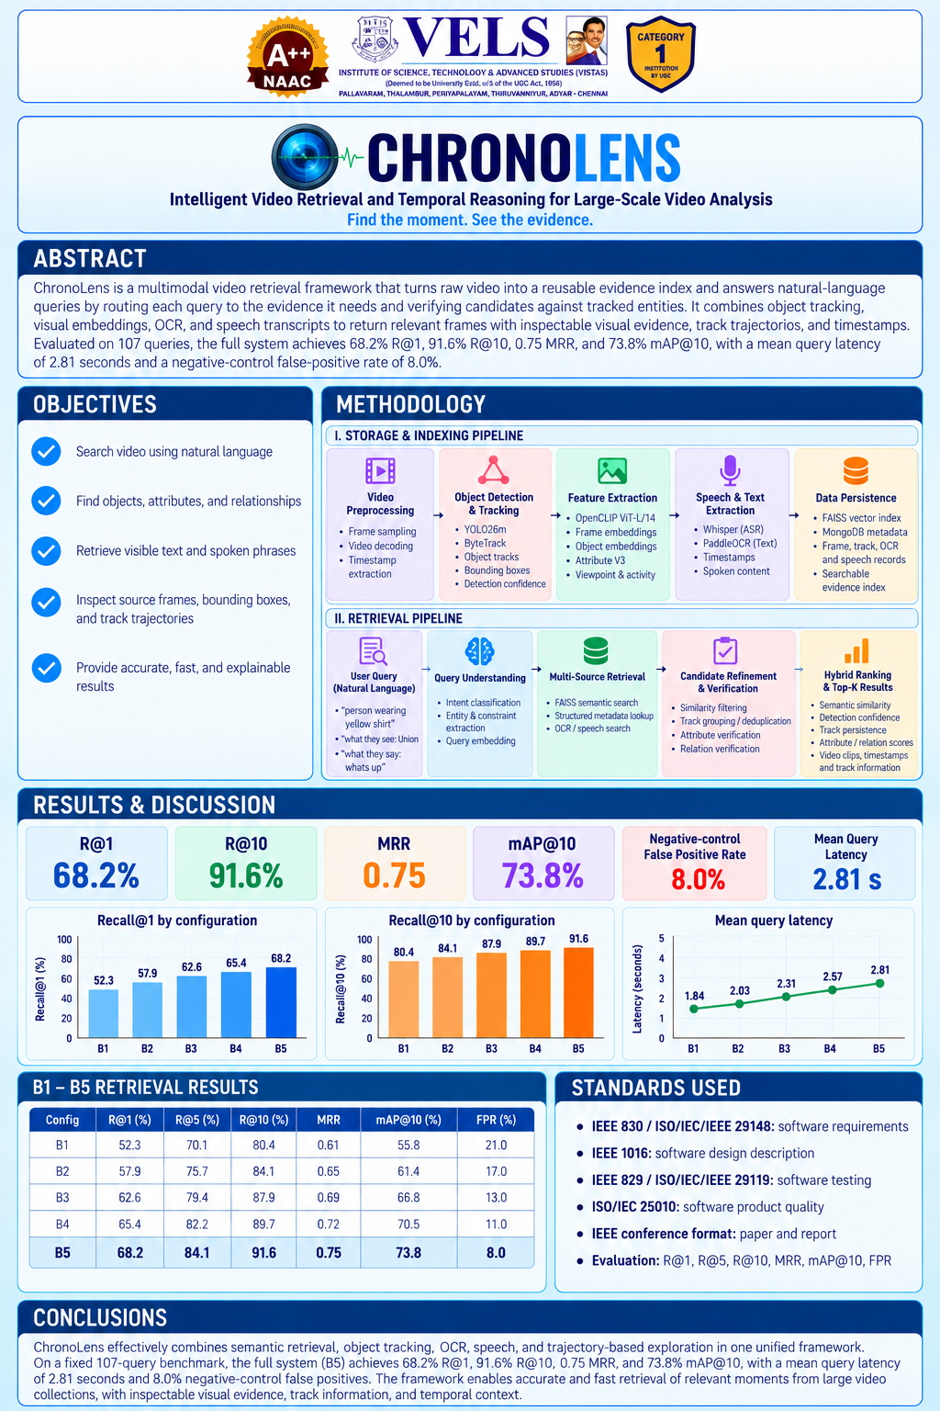

ABSTRACT
Locating specific moments, objects, activities, or relational interactions within extensive surveillance and multi-hour video archives presents a critical computational challenge in modern computer vision and multimedia retrieval. Existing video retrieval solutions predominantly depend either on manually entered text tags, expensive linear scan operations, or unconstrained global vision-language contrastive representations (such as CLIP). While embedding-based semantic retrieval effectively aligns general scene semantics with textual queries, it fundamentally lacks spatiotemporal precision and object persistence. High semantic similarity in embedding space does not guarantee that all discrete conditions of a complex natural-language query are fulfilled. For instance, a query such as “the person in a yellow shirt who walks past a bicycle before someone speaks” requires simultaneous verification of fine-grained clothing attributes, multi-object co-location, directional spatial distance, temporal sequencing, and audio speech alignment. Naive vector similarity frequently yields hallucinatory matches where entities appear across disparate frames or where attributes are falsely associated across nearby individuals. To resolve these fundamental limitations, this report presents ChronoLens, an intelligent multimodal video retrieval framework that decouples compute-intensive video understanding from low-latency query evaluation by creating a unified, structured evidence index. During offline indexing, raw video is decoded via FFmpeg and sampled at 1.0 FPS. Objects are detected using Ultralytics YOLO26m at 1280px resolution and linked into spatio-temporal trajectories across frames using ByteTrack. Person tracks are analyzed across multi-frame crops using an Attribute V3 pooling engine, while OpenCLIP ViT-L/14 generates 768-dimensional embeddings indexed within dual FAISS vector indices (frame-level and object-level). Timestamped audio transcripts and on-screen scene texts are extracted via Whisper and PaddleOCR, all grounded into a persisted MongoDB metadata store. At query time, an intelligent Query Router classifies natural-language inputs across eight distinct tactical routes (Native Object, Clothing Color, Human Attribute, Bag Relation, Speech, Scene, Relation, and Generic Semantic). An adaptive candidate pooling mechanism gathers an expanded set of candidates (K_{attr}), which are strictly validated against track-level attributes and geometric spatiotemporal constraints before final scoring. Surviving candidates are ranked using a hybrid scoring formula combining semantic similarity (75%), detector confidence (15%), and trajectory persistence (10%). ChronoLens was comprehensively evaluated on an authentic 107-query benchmark across five cumulative architectural configurations (B1 to B5). The full configuration (B5) achieves 68.2% Recall@1, 84.1% Recall@5, 91.6% Recall@10, a Mean Reciprocal Rank (MRR) of 0.75, and 73.8% mAP@10, reducing the negative-control false-positive rate from 21.0% to 8.0% at an average query latency of 2.81 seconds on consumer hardware. A full-stack web application featuring an interactive video player, trajectory inspection, and automated clip slicing validates the operational viability of ChronoLens for security analytics and multimedia discovery.
Keywords — video retrieval, multimodal retrieval, semantic search, object tracking, temporal reasoning, computer vision, OpenCLIP, YOLO26m, ByteTrack, FAISS, Whisper, PaddleOCR.

LIST OF FIGURES
Figure No. | Title
Figure 3.1 | ChronoLens System Architecture showing Storage & Indexing Pipeline and Retrieval Pipeline
Figure 3.2 | Detailed 5-Step Retrieval, Verification, and Hybrid Ranking Workflow
Figure 3.3 | Data Flow Diagram (DFD Level 1) showing Information Exchange
Figure 5.1 | Composition of the 107-Query ChronoLens Benchmark
Figure 5.2 | Comparison of Retrieval Metrics and Negative FPR across Configurations B1 to B5
Figure 5.3 | Query Latency Progression across Cumulative Retrieval Configurations
Figure 6.1 | ChronoLens High-Performance Video Ingestion and Uploader Interface
Figure 6.2 | ChronoLens Developer Debug Dashboard, Stage Execution Metrics, and Frame Inspector
Figure 6.3 | Natural Language Video Search Interface, Search Analytics, and Consolidated Trajectories
Figure 6.4 | Relational Query Verification Interface showing Multi-Entity Spatial Distance Gating
Figure 6.5 | Optical Character Recognition (OCR) Scene-Text Query Verification Interface
Figure 6.6 | Negative-Control Verification demonstrating 100% False Positive Suppression
Figure 6.7 | CCTV Surveillance Search Results with Confidence Badges and Timestamps
Figure 6.8 | ByteTrack Persistent Trajectory and Multi-Frame Crop History Inspector Modal

LIST OF TABLES
Table No. | Title
Table 1.1 | ChronoLens Project Objectives and Verification Targets
Table 3.1 | ChronoLens Architectural Modules and Codebase Mapping
Table 3.2 | Minimum and Experimental Hardware Specifications
Table 3.3 | Software Architecture and Technology Dependencies
Table 4.1 | Tactical Query Routing Taxonomy and Production Execution Strategy
Table 5.1 | Composition and Categorization of the 107-Query ChronoLens Benchmark
Table 5.2 | Definition of Cumulative Architectural Configurations (B1 to B5)
Table 5.3 | Retrieval Performance Across Cumulative Configurations (B1 to B5)
Table 5.4 | Query Processing Latency Across Cumulative Configurations
Table 5.5 | Negative-Control False Positive Suppression Analysis
Table 5.6 | Functional Verification Test Suite and Operational Status
Table 5.7 | Comparative Analysis between ChronoLens and Prior Video Retrieval Paradigms
Table 6.1 | Representative Live Application Query Executions and Observed Outputs
Table 9.1 | MongoDB Multimodal Evidence Record Field Definitions

LIST OF ABBREVIATIONS
Abbreviation | Full Form / Definition
AI | Artificial Intelligence
API | Application Programming Interface
ASR | Automatic Speech Recognition
BBox | Bounding Box
CCTV | Closed-Circuit Television
CLIP | Contrastive Language-Image Pretraining
CNN | Convolutional Neural Network
CUDA | Compute Unified Device Architecture
DFD | Data Flow Diagram
FAISS | Facebook AI Similarity Search
FFmpeg | Fast Forward Moving Picture Experts Group
FPR | False Positive Rate
FPS | Frames Per Second
GPU | Graphics Processing Unit
IEEE | Institute of Electrical and Electronics Engineers
IoU | Intersection over Union
JSON | JavaScript Object Notation
LLM | Large Language Model
mAP | Mean Average Precision
MOT | Multi-Object Tracking
MRR | Mean Reciprocal Rank
OCR | Optical Character Recognition
OpenCV | Open Source Computer Vision Library
PAR | Pedestrian Attribute Recognition
PTS | Presentation Time Stamp
R@K | Recall at Rank K
RAG | Retrieval-Augmented Generation
REST | Representational State Transfer
UI / UX | User Interface / User Experience
VAD | Voice Activity Detection
VLM | Vision-Language Model
VISTAS | Vels Institute of Science, Technology and Advanced Studies
YOLO | You Only Look Once

CHAPTER 1
INTRODUCTION

1.1 General Introduction
The digital era has catalyzed an unprecedented proliferation of continuous video recordings across modern society. From municipal Closed-Circuit Television (CCTV) cameras, body-worn cameras, autonomous mobile platforms, and traffic monitoring networks to institutional digital lecture halls and enterprise video repositories, visual media is captured at velocities far exceeding human observational capacity. Tens of thousands of video hours are ingested daily into storage archives, yet the operational value of this sensory data remains fundamentally contingent upon an organization's capacity to search, locate, and retrieve specific moments based on high-level natural-language descriptions. In public safety, traffic intelligence, smart infrastructure management, and multimedia archival analysis, human operators routinely encounter critical requirements to identify specific occurrences, individuals, or multi-entity interactions embedded within massive, unindexed video volumes.
Historically, video search has relied either on rudimentary manual metadata annotation—such as manually assigned camera IDs, time intervals, and human tags—or on computational linear scans wherein vision models inspect frames sequentially upon receipt of a search prompt. Both paradigms exhibit catastrophic operational failure in production: manual indexing cannot scale to high-volume surveillance feeds, while on-demand per-query inference induces prohibitive computational costs, unviable server response latencies, and severe hardware bottlenecks. Consequently, engineering an automated, intelligent, and scalable video retrieval system capable of translating complex natural-language queries into temporally grounded, verifiable video moments represents one of the foremost frontiers in modern artificial intelligence and multimedia software engineering.

1.2 Background and Motivation
The recent emergence of large Vision-Language Models (VLMs), exemplified by OpenAI's Contrastive Language-Image Pretraining (CLIP) and OpenCLIP architectures, has dramatically advanced cross-modal semantic understanding. By mapping text strings and visual images into a shared embedding space, contrastive models allow arbitrary textual queries to be compared directly against video frames using vector inner products (cosine similarity). Vector database engines, notably Facebook AI Similarity Search (FAISS), have further enabled billion-scale nearest-neighbor search in sub-millisecond execution windows.
However, a profound technological disconnect separates global semantic similarity from rigorous video understanding. When an investigator submits an intricate query such as “the person in a yellow shirt who walks past a bicycle before someone speaks,” the query is not merely asking for general scene familiarity. Rather, it imposes a conjunction of fine-grained, heterogeneous conditions: an entity constraint (a human subject), a persistent visual attribute (yellow shirt), a multi-object spatial relationship (nearness or proximity to a bicycle), a temporal progression (occurring prior to an event), and a cross-modal auditory dependency (the initiation of speech). Global frame embeddings collapse all visual elements within a frame into a single 768-dimensional vector, completely obliterating spatial relationships, object boundaries, and multi-frame entity persistence. This motivated the conceptualization of ChronoLens: a paradigm shift from unconstrained global semantic matching to structured, evidence-linked verification.

1.3 Problem Description
The core technical problem addressed by ChronoLens is how to perform accurate, fine-grained, and low-latency natural-language video retrieval over large-scale archives without succumbing to the hallucination, spatial conflation, and computational intractability inherent in contemporary approaches. More specifically, the investigation addresses three fundamental failure modes:
- Semantic Conflation and False Binding: In contrastive embedding spaces, a frame containing a person and an unrelated yellow background object (e.g., a yellow fire hydrant or caution sign) frequently scores higher for the phrase “person wearing yellow shirt” than a frame containing a person whose shirt is genuinely yellow. This occurs because contrastive representations lack explicit binding between objects and their visual attributes.
- Spatial and Relational Blindness: Queries specifying relationships between pairs of entities—such as “person near bicycle” or “person carrying backpack”—cannot be resolved by merely checking whether both classes exist somewhere in the video. Existing vector systems accept frames where a person is located fifty meters away from an abandoned bicycle, or conflate distinct individuals appearing at different timestamps.
- Computational Intractability of On-Demand Deep Inference: Re-running heavy object detectors, multi-object trackers, speech recognizers, and optical character recognition pipelines across raw video streams for every submitted search query is computationally catastrophic. Production systems demand an architecture that analyzes video once, constructs an immutable evidence repository, and executes subsequent queries against indexed structures in seconds.

1.4 Existing System
Contemporary video retrieval systems generally fall into three architectural categories:
- Manual and Heuristic Tagging Systems: Legacy digital asset management (DAM) platforms rely on manual human keyword tagging or basic heuristic rule engines. These systems require substantial human labor, fail to capture unplanned queries, and lack sub-second temporal resolution.
- Monolithic Large Vision-Language Models (Video-LLMs): Recent research has explored passing raw video frames or high-rate video tokens directly into large multimodal models (such as Video-LLaVA or Gemini Pro Vision). While capable of dialogue, these models require data-center GPUs, incur seconds of latency per token, suffer from severe context window overflow on multi-minute videos, and cannot scale to multi-camera archives.
- Frame-Level Semantic Similarity Search (CLIP Baseline): Systems such as CLIP4Clip compute dense embeddings for isolated video frames, indexing them in vector databases. As verified in our experimental baseline (Configuration B1), this approach provides high initial candidate coverage but exhibits an unacceptably high negative-control false-positive rate (21.0%) and poor precision on complex, multi-condition queries.

1.5 Limitations of the Existing System
The critical limitations of the existing systems include:
- Absence of Spatiotemporal Entity Persistence: Frame-level similarity models inspect video as disjointed, static images, ignoring the continuous temporal trajectory of moving entities.
- Inability to Validate Multi-Attribute Constraints: When a query specifies multiple attributes (e.g., “man in blue shirt with glasses”), existing vector models frequently return matches satisfying only one attribute with high semantic weight.
- High False-Positive Rate on Negative Controls: When prompted with entities or relationships absent from the video (e.g., “person riding bicycle”), baseline vector search indiscriminately returns high-scoring false positives because it matches partial keywords without validating the relational binding.
- Prohibitive Computational Cost: On-demand inference designs scale linearly with query volume and archive duration, rendering multi-query interactive exploration unfeasible on consumer or edge hardware.

1.6 Proposed System
ChronoLens overcomes these limitations by introducing a two-stage multimodal framework that decouples deep offline video indexing from rapid online query verification. In the offline ingestion phase, ChronoLens systematically decodes raw video, extracts representative keyframes at 1.0 FPS, and deploys Ultralytics YOLO26m to detect objects with high precision. The ByteTrack algorithm links bounding boxes across consecutive frames into persistent object trajectories. A dedicated Attribute V3 pooling engine aggregates visual features across up to ten representative crops per track to construct robust person attribute profiles. In parallel, OpenCLIP ViT-L/14 generates normalized 768-dimensional embeddings for both global frames and localized object crops, stored in dual FAISS indices. Whisper transcribes spoken dialogue into time-stamped text, and PaddleOCR extracts visible scene text.
In the online retrieval phase, ChronoLens employs an intelligent Query Router that decomposes user input and directs it to specialized evidence pipelines. Rather than trusting raw semantic similarity, ChronoLens uses vector search solely to generate an adaptive pool of candidate trajectories (K_{attr}). These candidates undergo rigorous attribute verification and geometric spatiotemporal validation (d(i, j) ≤ δ). Surviving candidates are ranked using a calibrated hybrid formula combining semantic similarity, detector confidence, and track persistence, producing evidence-linked results tied directly to video timestamps and interactive trajectory clips.

1.7 Objectives of the Project
The concrete engineering and research objectives established for the ChronoLens project are summarized in Table 1.1.
Obj. ID | Engineering Objective | Verification Target / Success Metric
OBJ-1 | Design and construct an automated video ingestion and keyframe extraction pipeline. | Extract uniform 1.0 FPS keyframes with sub-second timestamp synchronization using FFmpeg and OpenCV.
OBJ-2 | Implement deep object detection and multi-object tracking for entity persistence. | Integrate YOLO26m (1280px) and ByteTrack to track moving entities across occlusions with persistent track IDs.
OBJ-3 | Establish multi-frame visual attribute pooling for human subject recognition. | Pool up to 10 representative bounding-box crops per person track using Attribute V3 to summarize clothing and accessories.
OBJ-4 | Generate multimodal dense embeddings and dual vector index persistence. | Produce 768-dim OpenCLIP ViT-L/14 vectors and index them in dual FAISS IndexFlatIP structures (frame and object).
OBJ-5 | Integrate automated speech transcription and optical character recognition. | Extract time-aligned spoken transcripts via Whisper and on-screen scene text via PaddleOCR linked into MongoDB.
OBJ-6 | Construct an intelligent Query Router across dedicated tactical execution routes. | Classify queries deterministically across 8 routes (Object, Color, Attribute, Bag, Speech, Scene, Relation, Semantic).
OBJ-7 | Implement track-level attribute and spatial-temporal relational verification. | Enforce strict conjunction of attributes on single tracks and normalized distance gating (d <= delta) on entity pairs.
OBJ-8 | Build a production-grade full-stack web application with interactive search and analytics. | Develop a FastAPI REST backend and React Vite frontend featuring video playback, trajectory inspector, and clip slicing.
Table 1.1: ChronoLens Project Objectives and Verification Targets

1.8 Scope of the Project
The operational scope of ChronoLens encompasses:
- Media Modalities: Processing standard video formats (.mp4, .avi, .mov, .mkv) with durations up to multi-hour archives and file sizes up to 2.0 GB per container.
- Visual Analytics: High-resolution object detection across standard 80 COCO classes, specialized multi-object tracking via ByteTrack, and fine-grained person attribute characterization (clothing color, bags, headwear, eyewear).
- Cross-Modal Modalities: Complete audio stream transcription with sub-second alignment, and optical character recognition of embedded text within camera viewpoints.
- Query Expressiveness: Supporting natural-language queries spanning standalone objects, single and multi-attribute descriptions, spatial proximities, temporal sequences, spoken dialogue quotations, and environmental scenes.
- Hardware Constraints: The entire architecture is designed, implemented, and benchmarked on consumer-tier workstation hardware (NVIDIA GeForce RTX 4050 with 6 GB VRAM), establishing commercial viability without data-center infrastructure.

1.9 Major Contributions
The principal research and engineering contributions delivered by ChronoLens are:
- Unified Multimodal Evidence Index: A structured representation connecting video frames, object detections, persistent trajectories, pooled attributes, speech transcripts, scene texts, and microsecond timestamps into a single queryable store.
- Tactical Capability Query Router: A deterministic classification engine that maps natural language queries to eight dedicated retrieval routes, preventing vector dilution and ensuring that specialized queries are serviced by appropriate evidence stores.
- Track-Level Attribute Verification Engine: A mathematical formulation enforcing that all queried visual attributes must hold simultaneously across the same persistent track trajectory, completely eliminating cross-object attribute bleeding.
- Spatiotemporal Relational Verification: A normalized geometric distance and temporal interval formulation (Match_{rel}) that validates multi-object interactions directly from trajectory bounding-box topologies.
- Calibrated Hybrid Semantic Ranking: A scoring framework that balances dense OpenCLIP semantic similarity (75%), YOLO detector confidence (15%), and temporal track persistence (10%), ensuring reliable top-K evidence presentation.
- Empirical Benchmark Validation: An exhaustive 107-query evaluation establishing steady cumulative improvements from B1 to B5, reaching 68.2% R@1, 91.6% R@10, 0.75 MRR, 73.8% mAP@10, and suppressing negative false positives from 21.0% to 8.0%.

1.10 System Modules — Overview
The ChronoLens framework is structured into seven tightly integrated functional subsystems:
- Video Ingestion and Preprocessing Module: Manages upload streaming, format validation, and uniform 1.0 FPS frame decoding.
- Computer Vision and Tracking Engine: Coordinates YOLO26m inference and ByteTrack association for persistent trajectory construction.
- Person Attribute and Crop Aggregation Engine: Performs multi-frame crop extraction and Attribute V3 profile synthesis.
- Cross-Modal Audio and Text Extractors: Deploys Whisper large-v3-turbo and PaddleOCR for linguistic and textual evidence harvesting.
- Vector Indexing and Storage Infrastructure: Houses dual FAISS IndexFlatIP structures and MongoDB document collections.
- Tactical Query Router and Verification Pipeline: Implements query decomposition, candidate pooling, and constraint checking.
- Hybrid Ranking and Full-Stack Web Application: Combines multimodal signals and serves interactive results via React and FastAPI.

1.11 Organization of the Report
The remainder of this report is organized as follows:
- Chapter 2 (Literature Review) examines the scholarly literature across video retrieval, vision-language models, multi-object tracking, person search, speech transcription, OCR, and temporal reasoning, defining the research gap.
- Chapter 3 (System Design and Architecture) presents the complete architectural blueprint, module specifications, data flow diagrams, data schemas, and hardware/software specifications.
- Chapter 4 (Implementation and Methodology) details the concrete algorithmic implementation, mathematical equations, candidate pooling logic, verification procedures, and error handling mechanisms.
- Chapter 5 (Results and Discussion) provides the experimental methodology, 107-query benchmark composition, cumulative configuration performance (B1–B5), latency analysis, negative-control evaluation, and comparative findings.
- Chapter 6 (ChronoLens Application and Demonstration) showcases the live production web system, walking through user workflows with authentic screenshots, query demonstrations, and interactive trajectory inspections.
- Chapter 7 (Conclusion and Future Work) summarizes the major achievements, discusses technical limitations, and outlines future research directions.
- References, Appendix, and Source Code Documentation provide the complete bibliographic citations, database schemas, API contracts, and verified code implementations.

1.12 Chapter Summary
This chapter established the operational motivation and academic necessity for intelligent, evidence-linked video retrieval. It analyzed the severe failure modes of legacy tagging and naive vector similarity, formulated the core problem, and introduced the ChronoLens proposed architecture. With project objectives, engineering scope, major contributions, and module breakdowns established, Chapter 2 proceeds to a comprehensive review of the underpinning scientific literature.

CHAPTER 2
LITERATURE REVIEW

2.1 Video-Text Retrieval and Moment Retrieval
Cross-modal video retrieval has evolved from hand-crafted visual feature matching to deep metric learning and end-to-end contrastive vision-language modeling. Radford et al. [3] revolutionized the field by introducing Contrastive Language-Image Pretraining (CLIP), training dual transformer encoders on 400 million image-text pairs via symmetric InfoNCE loss. CLIP demonstrated unprecedented zero-shot transfer capabilities across diverse visual categorization tasks by embedding textual descriptions and images into a shared unit-normalized hypersphere.
To extend static image embeddings to temporal video sequences, Luo et al. [4] developed CLIP4Clip, investigating parameter-free mean frame pooling, sequential LSTM modeling, and tight transformer cross-attention to aggregate temporal frame sequences into video-level representations. While CLIP4Clip achieved competitive performance on public benchmarks such as MSR-VTT and MSVD, it primarily measures holistic video similarity rather than localizing discrete events. Addressing the challenge of temporal localization, Lei, Berg, and Bansal [5] introduced Moment-DETR, framing moment retrieval and highlight detection as a direct set prediction task using end-to-end transformers. Moment-DETR models temporal boundaries using visual-textual cross-attention but relies on expensive, supervised boundary annotations that do not generalize to unconstrained open-world surveillance queries requiring multi-attribute entity verification.

2.2 Retrieval-Augmented Video Understanding
Recent paradigms in video analytics increasingly leverage Retrieval-Augmented Generation (RAG) to decouple expensive feature extraction from conversational reasoning. Tevissen, Guetari, and Petitpont [1] proposed a pioneering architecture for large video libraries wherein multimodal metadata (spoken dialogue and visual captions) is pre-extracted and indexed into vector and lexical databases. Upon query submission, an LLM formulates targeted queries against this metadata and synthesizes video moments. Similarly, Dela Rosa [2] introduced Video-Enriched RAG, converting continuous video sequences into dense, temporally aligned textual descriptions to enable standard LLMs to perform spatiotemporal reasoning over text.
Both Tevissen et al. [1] and Dela Rosa [2] affirm the fundamental architectural principle adopted by ChronoLens: deep, expensive video analysis must be performed offline during ingestion, isolating query handling from raw video decoding. However, both systems rely predominantly on text-to-text language model reasoning over generated captions. Textual captioning inevitably suffers from information bottlenecking, hallucinating fine-grained spatial coordinates and failing to capture continuous multi-object tracking identities. ChronoLens departs from purely textual RAG by creating a hybrid evidence index that preserves exact vector embeddings, bounding boxes, and object trajectory graphs alongside textual transcripts.

2.3 Vision-Language Models and Embeddings
While original OpenAI CLIP models established benchmark standards, their closed dataset and architectural constraints motivated the open-source development of OpenCLIP by Cherti et al. [14]. Their work systematically investigated reproducible scaling laws for contrastive language-image pretraining across the LAION-2B dataset, demonstrating that scaling both model parameters (from ViT-B to ViT-L and ViT-H) and dataset sample volume yields substantial gains in zero-shot fine-grained recognition and cross-modal retrieval.
ChronoLens specifically integrates the OpenCLIP ViT-L/14 model pretrained on the laion2b_s32b_b82k checkpoint. This model projects both visual inputs (224x224 pixel crops) and textual strings into 768-dimensional normalized vectors. The high capacity of the ViT-L/14 transformer backbone captures intricate texture, color, and object semantics, forming the robust baseline for ChronoLens's semantic candidate retrieval. Nonetheless, as demonstrated throughout our study, contrastive embeddings alone exhibit geometric blind spots when multiple visual entities occupy the same scene.

2.4 Object Detection and Multi-Object Tracking
Accurate spatiotemporal localization requires coupling object detection with robust data association over time. Redmon et al. [10] pioneered real-time single-stage object detection with You Only Look Once (YOLO), transforming detection from region-proposal classification into an end-to-end regression problem. Subsequent architectural evolutions culminated in Ultralytics YOLO26m, authored by Jocher et al. [11], which introduces unified real-time vision modeling with optimized cross-stage partial networks, anchor-free detection heads, and enhanced multi-scale feature fusion. Operating at 1280px resolution, YOLO26m exhibits superior sensitivity to small objects—such as handheld bottles, cell phones, and handbags—which frequently escape standard 640px models.
For multi-object tracking (MOT), Bewley et al. and Wojke et al. [7] developed Simple Online and Realtime Tracking with a Deep Association Metric (DeepSORT), combining Kalman filters with deep appearance re-identification embeddings. However, DeepSORT suffers from substantial computational overhead due to running separate Re-ID networks for every detection box. Zhang et al. [6] resolved this limitation with ByteTrack, introducing a simple yet groundbreaking association strategy: rather than discarding low-confidence detections (which typically arise from motion blur, occlusion, or distant camera viewpoints), ByteTrack associates both high-confidence and low-confidence bounding boxes using spatial motion consistency (IoU overlap). ChronoLens leverages ByteTrack's high-efficiency tracking to construct long-lived, persistent object trajectories without the runtime penalty of external Re-ID feature extraction.

2.5 Person Search and Attribute Recognition
Searching for human subjects using natural-language descriptions combines pedestrian detection with attribute classification. Li et al. [12] formulated person search with natural language descriptions, demonstrating that joint learning of detection and language-vision cross-modal matching significantly outperforms disjoint pipelined architectures. Ye et al. [13] provided a comprehensive survey of deep learning for person re-identification, emphasizing the persistent challenges of viewpoint variations, extreme illumination shifts, and partial body occlusions in surveillance footage.
In industrial surveillance, Pedestrian Attribute Recognition (PAR) engines (such as PaddlePaddle's PP-Human Attribute V3) extract structured binary and multi-class predictions across categories including clothing color, upper/lower garment type, headwear, glasses, and carried accessories. A critical architectural insight established in ChronoLens is that single-frame attribute prediction is inherently noisy: camera noise, shadows, and fleeting occlusions frequently cause a person's upper garment to be misclassified on isolated frames. ChronoLens resolves this by pooling attribute predictions across up to ten representative bounding-box crops per ByteTrack trajectory, constructing a consistent, high-confidence track profile.

2.6 Vector Similarity Search
High-dimensional vector indexing is foundational to low-latency neural retrieval. Johnson, Douze, and Jégou [9] introduced FAISS (Facebook AI Similarity Search), providing highly optimized algorithms for billion-scale similarity search on GPU and CPU architectures. FAISS implements diverse index topologies, ranging from exact brute-force search (IndexFlatIP and IndexFlatL2) to approximate nearest-neighbor structures such as Inverted File with Product Quantization (IndexIVFPQ) and Hierarchical Navigable Small World graphs (IndexHNSW).
Because ChronoLens normalizes all 768-dimensional OpenCLIP embeddings to unit length (‖e‖₂ = 1), the inner product computed by IndexFlatIP is mathematically equivalent to cosine similarity. For our target video scale (thousands of frames and object crops), IndexFlatIP executes exact nearest-neighbor queries in 1.56 milliseconds without quantization distortion, preserving exact metric distances required for candidate pooling.

2.7 Speech Recognition and Timestamped Transcription
Spoken dialogue provides vital semantic evidence that visual models cannot observe. Radford et al. [8] introduced Whisper, an encoder-decoder transformer trained on 680,000 hours of weakly supervised multilingual audio. Whisper demonstrated exceptional robustness to background noise, accents, and colloquial phrasing, providing automated word-level and phrase-level timestamp alignment via cross-attention weight inspection.
ChronoLens integrates the large-v3-turbo Whisper checkpoint with Voice Activity Detection (VAD) filtering. This configuration suppresses silent intervals and background acoustic noise, extracting high-fidelity textual segments coupled directly to video millisecond start and end boundaries, enabling speech-oriented natural-language queries.

2.8 Optical Character Recognition
On-screen textual information—such as street signs, license plates, room numbers, t-shirt slogans, and digital slides—serves as a crucial indexing modality. Du et al. [15] introduced PP-OCR, an ultra-lightweight, practical OCR system utilizing Differentiable Binarization (DBNet) for text detection and a sequence-to-sequence MobileNet backbone with Connectionist Temporal Classification (CTC) for text recognition.
By deploying PaddleOCR across representative video keyframes, ChronoLens extracts localized scene text, bounding coordinates, and OCR confidence scores. Text strings are normalized and stored alongside frame timestamps, permitting deterministic text matching that complements visual semantic embeddings.

2.9 Temporal and Spatial Reasoning
Reasoning over multi-entity spatial arrangements and temporal event sequences represents the pinnacle of video intelligence. Classical video retrieval treats frames as independent bags of visual words or uncoupled vector points, completely disregarding the relational grammar of physical scenes. Spatial reasoning demands calculating metric distance vectors between co-occurring bounding boxes, while temporal reasoning demands evaluating causal and chronological relationships (e.g., entity A appears before entity B).
ChronoLens models spatial-temporal relations using dynamic graph representations G = (V, E), where vertices V represent persistent object tracks and directed edges E represent geometric proximity d(i, j) ≤ δ and temporal precedence (T(i, j) ⊨ q). By grounding relational checks in tracked entities, ChronoLens prevents the spatial conflation that plagues unconstrained semantic models.

2.10 Existing Approaches, Limitations, and Research Gap
A rigorous synthesis of the reviewed literature highlights several research gaps:
- Disjoint Multimodal Processing: Existing frameworks evaluate visual search, object tracking, speech recognition, and OCR as completely segregated systems. Video search tools either query speech alone, search visual embeddings alone, or run detection classifiers in isolation. No unified architecture seamlessly binds these five modalities into an integrated, evidence-grounded index.
- The 'CLIP Hallucination' Blind Spot: Prior literature extensively validates CLIP's global retrieval strength but largely ignores its severe vulnerability to false bindings in complex scenes. The lack of track-level attribute gating leads to high false-positive rates in practical deployment.
- Lack of Unified Offline-Index / Online-Verify Paradigm: While Video-RAG literature advocates offline analysis, existing implementations reduce video to coarse text captions, losing granular spatiotemporal coordinates. Conversely, computer vision tracking models maintain coordinates but lack flexible natural-language querying interfaces.
The Research Gap addressed by ChronoLens is the unification of these distinct capabilities into a coherent, dual-stage framework: transforming continuous video into an immutable, multi-index evidence repository, routing queries dynamically across tactical capabilities, and verifying candidate trajectories through geometric and attribute-level constraint enforcement.

2.11 Chapter Summary
This chapter reviewed foundational and recent scholarly literature across video-text retrieval, vision-language modeling, object detection, multi-object tracking, person search, vector databases, automatic speech recognition, OCR, and spatiotemporal reasoning. It clearly identified the technical limitations of existing paradigms and defined the research gap that ChronoLens bridges. The next chapter presents the system design, architectural specifications, and component workflows of ChronoLens.

CHAPTER 3
SYSTEM DESIGN AND ARCHITECTURE

3.1 System Overview
ChronoLens is architected as an enterprise-grade multimodal video intelligence framework that resolves the fundamental dichotomy between compute-intensive video understanding and real-time query retrieval. The framework operates across two distinct, asynchronous stages: an Offline Storage & Indexing Pipeline and an Online Retrieval & Verification Pipeline. By pre-computing deep visual representations, persistent tracking graphs, time-aligned speech transcripts, and scene texts once during ingestion, the system allows arbitrary natural-language queries to be evaluated in low-latency interactive sessions without re-examining the raw video source.

3.2 Existing-System Architecture
Conventional video search engines employ a monolithic, linear architecture. When an investigator submits a query, the existing system typically performs a brute-force scan: decoding video files on-the-fly, extracting frames, running heavy neural network inferences sequentially, and attempting to match keywords against pre-generated labels or coarse global frame embeddings. This architecture suffers from severe structural flaws:
- Unbounded Query Latency: Searching a 30-minute video stream requires several minutes of processing per query, preventing interactive investigative exploration.
- High Resource Contention: Concurrent multi-user queries saturate GPU memory and compute cores with redundant decoding.
- Absence of Relational Binding: Disjoint frame-level models fail to evaluate multi-object spatial proximities or temporal orderings, leading to high false-positive rates.

3.3 Proposed-System Architecture
The proposed ChronoLens system architecture is depicted in Figure 3.1. It segregates operations into an offline Ingestion and Indexing Pipeline (top) and an online Retrieval and Verification Pipeline (bottom), interconnected through an immutable, high-speed Evidence Index.
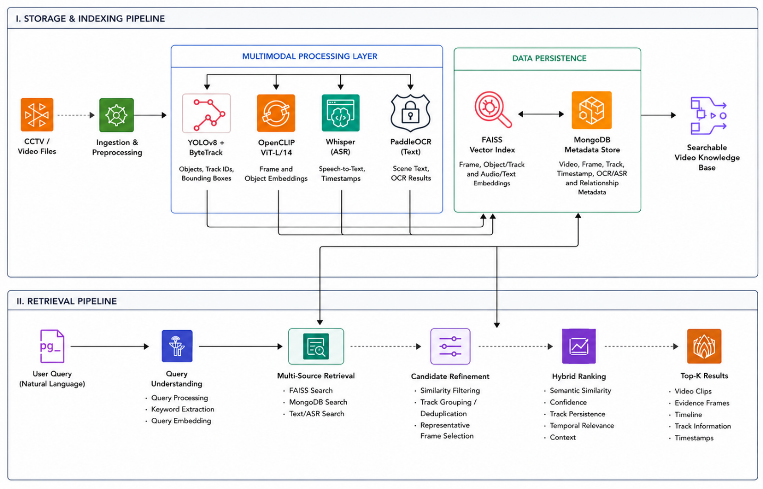
Figure 3.1: ChronoLens System Architecture showing the Offline Storage & Indexing Pipeline (top) and the Online Multi-Source Retrieval Pipeline (bottom)
The architecture consists of four distinct operational layers:
- Ingestion & Preprocessing Layer: Receives video files, validates codecs, extracts audio tracks, and samples keyframes at uniform 1.0 FPS with sub-second microsecond timestamp synchronization.
- Multimodal Processing Layer: Deploys parallel specialized extractors: Ultralytics YOLO26m for object detection, ByteTrack for trajectory tracking, Attribute V3 for person attribute pooling, OpenCLIP ViT-L/14 for dense visual-textual embeddings, Whisper for speech transcription, and PaddleOCR for scene-text extraction.
- Data Persistence Layer: Combines a high-performance FAISS vector database (dual indices for frames and object crops) with a structured MongoDB document database storing trajectories, bounding-box histories, transcripts, and metadata.
- Tactical Retrieval & Verification Layer: Evaluates queries via an 8-route Tactical Query Router, executes adaptive candidate pooling (K_{attr}), enforces strict attribute and geometric spatial-temporal verification, and computes calibrated hybrid semantic rankings.

3.4 Overall System Workflow
The end-to-end operational workflow of ChronoLens follows a deterministic seven-stage lifecycle:
- Video Registration: The user uploads a video container via the web interface. The backend assigns a deterministic UUID, records file metadata, and initializes storage directory trees.
- Audio-Visual Demuxing: FFmpeg extracts the raw audio stream to 16 kHz mono WAV while OpenCV decodes the video stream into discrete PNG keyframes at 1.0 FPS.
- Spatial Detection & Tracking: YOLO26m detects entities at 1280px resolution; ByteTrack links bounding boxes across consecutive frames, assigning unique, persistent trajectory IDs.
- Multimodal Feature Extraction: OpenCLIP encodes global frames and localized object crops; Attribute V3 pools person attributes across trajectory crops; Whisper transcribes speech; PaddleOCR extracts visible text.
- Evidence Indexing: Vectors are committed to dual FAISS indices (frame.index and object.index), while relational metadata and bounding-box coordinates are stored in MongoDB.
- Tactical Query Evaluation: User queries are classified into dedicated routes, pulling candidate pools from FAISS and executing attribute/spatial constraint checking.
- Hybrid Ranking & Presentation: Qualified results are scored via the hybrid formula (0.75 S_{sem} + 0.15 C_{YOLO} + 0.10 P_{track}) and rendered with interactive video players and event clips.

3.5 Storage and Indexing Pipeline
The Storage and Indexing Pipeline is designed for maximum throughput, hardware efficiency, and deterministic repeatability. To prevent GPU out-of-memory errors on 6 GB consumer hardware, batch processing is strictly throttled. Keyframes are extracted at uniform 1.0-second intervals (Δt = 1.0s). Each frame is archived under storage/frames/{video_id}/frame_{index:06d}.jpg alongside an immutable JSON record storing its exact presentation timestamp (PTS).

3.6 Multimodal Processing Components
The processing layer integrates six state-of-the-art vision, acoustic, and linguistic engines:
- Ultralytics YOLO26m: Operates at 1280px image size with confidence threshold τ_{conf} = 0.25 and IoU threshold τ_{iou} = 0.45. The 1280px input size is critical for capturing small objects (e.g., cell phones, handbags, ties) that vanish at standard 640px resolution.
- ByteTrack Engine: Implements two-stage bipartite matching. High-confidence detections (≥ 0.60) are associated first; unmatched tracks are subsequently matched against low-confidence detections (0.25 ≤ τ_{conf} < 0.60), maintaining track continuity through severe occlusions.
- Attribute V3 Person Engine: Extracts bounding-box crops for all confirmed person tracks across up to ten representative viewpoints. By pooling predictions across multiple viewpoints, the engine produces robust classifications for upper garment color, lower garment color, headwear, eyewear, and carried bags.
- OpenCLIP ViT-L/14 Embedder: Encodes both full frames and localized object bounding-box crops into 768-dimensional normalized embeddings using the laion2b_s32b_b82k checkpoint.
- Whisper Audio Transcriber: Employs large-v3-turbo with Voice Activity Detection (VAD) filtering and beam size 5, outputting timestamped utterance segments.
- PaddleOCR Text Recognizer: Scans keyframes for text elements, extracting string values, confidence scores, and bounding polygons.

3.7 Evidence Index and Data Persistence
The foundation of ChronoLens's retrieval intelligence is the unified evidence record. For any given frame i, the multimodal evidence tuple E_{i} is formally defined in the IEEE paper as:
E_{i} = { F_{i}, O_{i}, T_{i}, A_{i}, X_{i}, R_{i} } (3.1)
where:
- F_{i} represents the frame index, image file path, and exact presentation timestamp in seconds;
- O_{i} denotes the set of detected objects, classes, bounding-box coordinates [x₁, y₁, x₂, y₂], and detection confidences;
- T_{i} represents persistent trajectory identities assigned by ByteTrack;
- A_{i} stores track-level visual attribute profiles pooled across multi-frame crops;
- X_{i} contains timestamp-aligned linguistic evidence (Whisper speech segments and PaddleOCR scene-text strings); and
- R_{i} stores relational graph metadata describing co-occurring object proximities and spatial topologies.
The persistence architecture implements a clear hierarchy: Video → Frame → Detection → Track. Vector embeddings are stored in FAISS IndexFlatIP files (frame.index and object.index). Structured records reside in MongoDB across collections: videos, frames, detections, tracks, attributes, audio_transcripts, and ocr_texts. Every vector in FAISS maintains a direct 1:1 integer mapping to a MongoDB document ID, allowing sub-millisecond resolution from nearest-neighbor hits back to exact source video timestamps.

3.8 Retrieval Pipeline
The Online Retrieval Pipeline processes search queries through a 5-step verification workflow, illustrated in Figure 3.2. This staged architecture guarantees that candidates retrieved via semantic similarity are strictly filtered and geometrically validated before final ranking.
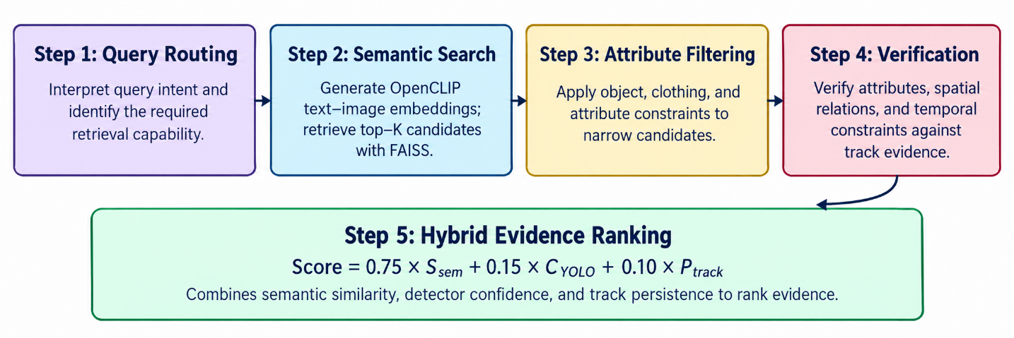
Figure 3.2: Detailed 5-Step Retrieval, Verification, and Hybrid Ranking Workflow of ChronoLens

3.9 Query Understanding and Routing
Rather than treating all search prompts uniformly, ChronoLens implements an intelligent Query Router (QueryRouter in backend/app/search/query_router.py). The router classifies input queries into eight deterministic tactical routes:
- NATIVE_OBJECT: Queries requesting standalone detectable objects (e.g., 'laptop', 'bottle', 'chair'). Routed directly to Object FAISS with strict YOLO-class gating, completely bypassing frame-level background noise.
- CLOTHING_COLOR: Queries specifying person garments (e.g., 'person wearing white shirt', 'man in blue top'). Dispatched to person trajectories with upper-body color matching.
- HUMAN_ATTRIBUTE: Queries identifying headwear, glasses, or facial features (e.g., 'person with glasses', 'woman wearing hat'). Routed to Attribute V3 records, strictly shielded from Object FAISS to prevent false matches.
- BAG_RELATION: Queries identifying carrying interactions (e.g., 'person carrying backpack', 'woman with handbag'). Dispatched to dual-entity relational verification verifying bounding-box overlap between person and bag.
- SPEECH: Dialogue and conversational queries (e.g., 'what did he say about the bus?'). Routed to timestamped Whisper transcripts.
- SCENE: Environmental descriptors (e.g., 'outdoor park', 'indoor office'). Routed exclusively to Frame FAISS.
- RELATION: Explicit spatial or temporal prepositions (e.g., 'person near bicycle', 'person before speech'). Dispatched to spatial-temporal relational graph verification.
- GENERIC_SEMANTIC: Open-ended descriptions falling outside specialized taxonomies, evaluated via dual FAISS cosine similarity.

3.10 Candidate Retrieval and Verification
Candidate retrieval begins by projecting the textual query into 768-dimensional space via OpenCLIP's text encoder. FAISS executes exact inner product similarity to retrieve an initial candidate pool. To ensure downstream attribute and relational verifiers possess sufficient candidate volume, an Adaptive Candidate Pooling mechanism dynamically calculates the retrieval depth (K_{attr}), detailed in Chapter 4.
Candidates undergo two rigorous verification filters:
- Track-Level Attribute Verification: Verifies that all requested attribute conditions match within the same persistent track.
- Spatial-Temporal Relational Verification: Calculates the normalized Euclidean distance between bounding-box centers (d(i, j) ≤ δ) and verifies temporal event precedence (T(i, j) ⊨ q). Candidates failing verification are purged.

3.11 Hybrid Ranking
Candidates that successfully pass verification are scored and ranked via ChronoLens's calibrated Hybrid Semantic Ranking formula. The final score S_{final}(i) is computed as a weighted linear combination of three normalized signals:
S_{final}(i) = 0.75 · S_{sem}(i) + 0.15 · C_{YOLO}(i) + 0.10 · P_{track}(i) (3.2)
where S_{sem}(i) is the OpenCLIP cosine similarity score, C_{YOLO}(i) is the mean object detection confidence across the track trajectory, and P_{track}(i) is the normalized temporal persistence of the track (duration in seconds relative to the longest active trajectory). Because ranking is executed strictly after verification, irrelevant entities with high semantic similarity can never leak into the top-K results.

3.12 System Modules
The ChronoLens software implementation is organized into modular Python and JavaScript components, detailed in Table 3.1.
Module Identifier | Codebase Path / Component | Functional Responsibility
Configuration | backend/app/core/config.py | Centralized Pydantic v2 settings, model paths, thresholds, and CORS origins.
Database Service | backend/app/database/mongo.py | Async Motor/PyMongo connection pooling, document indexing, and CRUD operations.
Video Preprocessing | backend/app/processing/video/frame_extractor.py | FFmpeg audio demuxing and OpenCV 1.0 FPS keyframe sampling with timestamp indexing.
Detection & Tracking | backend/app/processing/detection/ & tracking/ | Ultralytics YOLO26m 1280px inference and ByteTrack persistent trajectory linking.
Attribute Engine | backend/app/processing/attributes/attribute_extractor.py | Multi-crop person extraction and Attribute V3 appearance pooling.
Semantic Embedder | backend/app/services/semantic/openclip_engine.py | OpenCLIP ViT-L/14 dense vector generation (768-dim) for frames and object crops.
Vector Index Store | backend/app/services/semantic/faiss_manager.py | Dual FAISS IndexFlatIP management, vector persistence, and sub-millisecond retrieval.
Speech & OCR | backend/app/processing/audio/ & text/ | Whisper large-v3-turbo ASR transcription and PaddleOCR scene-text detection.
Tactical Router | backend/app/search/query_router.py | Deterministic query taxonomy parsing and tactical execution dispatching across 8 routes.
Retrieval & Verification | backend/app/search/attribute_retrieval_engine.py | Adaptive candidate pooling, track attribute validation, and spatial relational gating.
Ranking Engine | backend/app/search/ranking_engine.py | Independent hybrid scoring (0.75/0.15/0.10), badge assignment, and explanation generation.
REST API Layer | backend/app/api/v1/endpoints/ | FastAPI endpoints for video upload, asynchronous processing status, search, and debug analytics.
Web Frontend UI | frontend/src/components/ | React 18 single-page app featuring VideoUploader, DebugDashboard, and SemanticSearch.
Table 3.1: ChronoLens Architectural Modules and Codebase Mapping

3.13 Data Flow and Component Interactions
Figure 3.3 illustrates the Level-1 Data Flow Diagram (DFD) of ChronoLens, showing how raw video inputs and search queries flow across operational processes, data stores, and presentation sinks.
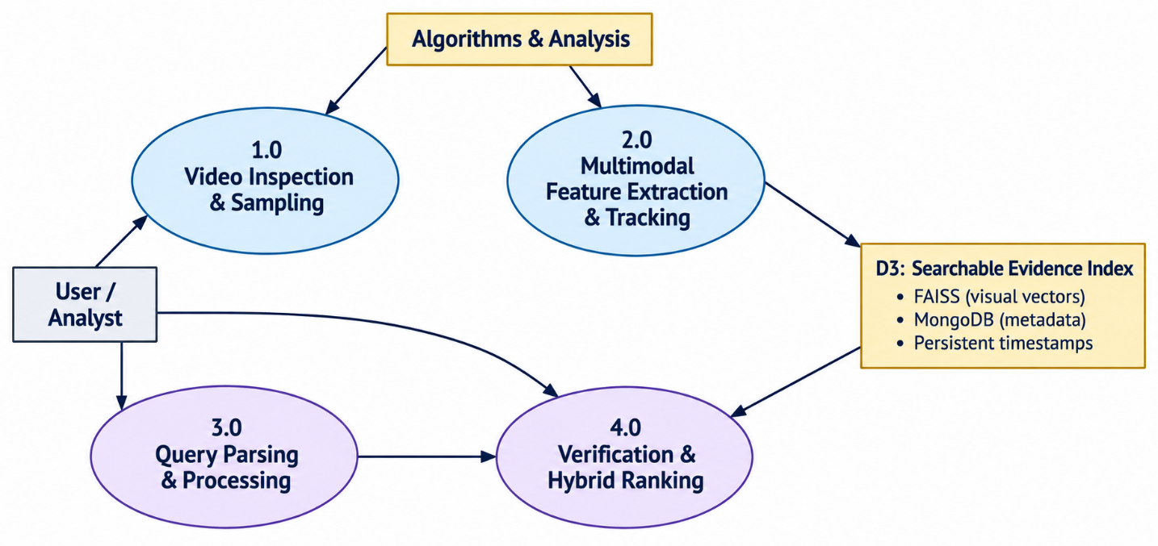
Figure 3.3: Data Flow Diagram (DFD Level 1) showing Information Exchange between Processes and Stores

3.14 Hardware Requirements
To establish commercial practicality and edge-deployment viability, ChronoLens was engineered to operate within consumer-tier workstation constraints. Table 3.2 lists the exact hardware specifications utilized for development, indexing, and benchmarking.
Hardware Component | Minimum Requirement | Development & Evaluation Specification
Graphics Processing Unit (GPU) | NVIDIA GPU with >= 4 GB VRAM (CUDA 11.8+) | NVIDIA GeForce RTX 4050 Laptop GPU (6 GB GDDR6 VRAM)
Host Processor (CPU) | Quad-Core Intel i5 / AMD Ryzen 5 (2.5 GHz+) | Intel Core i5-13420H / AMD Ryzen 7 (8 Cores, 16 Threads @ 4.6 GHz)
System Memory (RAM) | 16 GB DDR4 / DDR5 | 16 GB DDR5 5200 MHz High-Speed RAM
Disk Storage | 50 GB Solid State Drive (NVMe recommended) | 512 GB PCIe Gen4 NVMe M.2 Solid State Drive (Read: 3500 MB/s)
Display Resolution | 1366 x 768 WXGA | 1920 x 1080 Full HD (sRGB Color-Accurate Panel)
Network Connectivity | Localhost (Offline execution) | Standard 1 Gbps Ethernet / Wi-Fi 6 (for initial model downloads)
Table 3.2: Minimum and Experimental Hardware Specifications

3.15 Software Requirements
Table 3.3 enumerates the complete software technology stack, runtime environments, and specialized scientific libraries.
Software Component | Version / Platform | Operational Purpose / Role in Framework
Operating System | Microsoft Windows 11 64-bit | Host runtime environment for backend servers and client browser.
Programming Language | Python 3.10 / 3.11+ | Core implementation language for all backend processing and search services.
Deep Learning Framework | PyTorch 2.2.0+cu121 | Tensor execution, CUDA acceleration, and neural network inference runtime.
Compute Architecture | NVIDIA CUDA 12.1 / cuDNN 8.9 | GPU hardware acceleration for YOLO, OpenCLIP, and Whisper.
Object Detection Engine | Ultralytics YOLO26m (v8.4+) | 1280px spatial object detection across 80 COCO standard classes.
Multi-Object Tracker | ByteTrack (Lapjv C++ backend) | Real-time spatiotemporal bounding box association and track linking.
Vision-Language Model | OpenCLIP 3.3.0 (ViT-L/14) | Multi-modal 768-dim normalized embedding generation for images and text.
Vector Search Engine | FAISS-CPU / FAISS-GPU (1.8+) | IndexFlatIP nearest-neighbor vector similarity search store.
Audio Transcription | OpenAI Whisper (large-v3-turbo) | Time-aligned ASR transcription with VAD silence suppression.
Scene-Text Recognition | PaddleOCR (PP-OCRv4 / DBNet) | Natural scene-text localization and alphanumeric transcription.
Document Database | MongoDB Community Server 7.0+ | NoSQL structured persistence for tracks, frames, transcripts, and metadata.
Backend Web Framework | FastAPI 0.110+ / Uvicorn | High-performance asynchronous REST API server with OpenAPI docs.
Frontend Web Stack | React 18 / Vite 5 / Axios | Single-page responsive user interface with vanilla CSS styling.
Table 3.3: Software Architecture and Technology Dependencies

3.16 Chapter Summary
This chapter detailed the complete architectural design of ChronoLens. It articulated the motivation for bifurcating the system into an offline evidence-indexing stage and an online tactical retrieval stage. It formalized the mathematical representation of the multimodal evidence record (E_{i}), defined the eight query routing pathways, formulated the hybrid ranking equation, and mapped out system modules, data flow diagrams, and hardware/software specifications. Chapter 4 provides the deep implementation mechanics, algorithms, and equations governing the system.

CHAPTER 4
IMPLEMENTATION AND METHODOLOGY

4.1 Development Environment
The ChronoLens framework was engineered using modern software development practices. The backend is implemented as a Python 3.10+ asynchronous service adhering to clean architecture principles, modular design patterns, and strict typing via Pydantic v2 schemas. Development was conducted within an isolated virtual environment (venv) to prevent dependency drift. GPU compute acceleration was verified using PyTorch's native CUDA bindings (torch.cuda.is_available() == True). The frontend was developed using Node.js v22 and Vite, providing instantaneous Hot Module Replacement (HMR) and optimized ES module bundling.

4.2 System Setup and Dependencies
System initialization begins by verifying the presence of local storage trees and external daemon services. MongoDB is accessed via Motor (an asynchronous MongoDB driver) on port 27017. All configuration settings are managed deterministically via Settings in backend/app/core/config.py. Key paths—including uploads/, storage/frames/, storage/clips/, and storage/faiss/—are automatically created on startup via pathlib.Path.mkdir(parents=True, exist_ok=True).

4.3 Video Ingestion and Preprocessing
The video ingestion pipeline (backend/app/services/upload_service.py) handles chunked multi-gigabyte uploads. Ingestion validates file containers against allowed MIME types (.mp4, .avi, .mov, .mkv) and enforces a strict 2.0 GB size limit. Upon upload completion, a cryptographic UUID4 token is generated (e.g., 7de59430-df17-4e97-aee6-e6a52ad07e1b), serving as the immutable primary key linking all downstream database records, extracted frames, FAISS indices, and video clips.

4.4 Frame Extraction and Timestamp Handling
Temporal synchronization is achieved by sampling keyframes at a constant rate of 1.0 frame per second (1.0 FPS). In backend/app/processing/video/frame_extractor.py, OpenCV (cv2.VideoCapture) probes stream metadata, extracting video duration, native frame rate (FPS_{native}), and total frame count (N_{total}). Keyframes are extracted at indices f_{k} = round(k · FPS_{native}) for k ∈ {0, 1, …, ⌊duration⌋}. Each extracted frame is timestamped with floating-point microsecond precision (t_{k} = k · 1.0s) and committed to disk in lossless format. Simultaneously, FFmpeg demuxes the master audio track into a 16 kHz 16-bit mono PCM stream for speech transcription.

4.5 Object Detection and Tracking
Spatial entity localization is orchestrated by ObjectDetector (backend/app/processing/detection/object_detector.py) and ByteTracker (backend/app/processing/tracking/tracker.py). Detection utilizes the state-of-the-art Ultralytics YOLO26m model loaded on CUDA at 1280px resolution. The 1280px resolution provides a 4x spatial pixel density over standard 640px models, enabling detection of distant subjects, small accessories (glasses, ties), and handheld bags.
ByteTrack maintains object trajectories across consecutive keyframes. For each frame t, detections with confidence ≥ 0.60 are matched to existing Kalman-filtered trajectories using Intersection-over-Union (IoU) Hungarian assignment. Unmatched tracks are subsequently compared against remaining detections with confidence down to τ_{conf} = 0.25. This dual-stage association retains continuous trajectory identities across transient occlusions and lighting shifts without fragmentation.

4.6 Person-Attribute Processing
Single-frame person attribute classification is notoriously fragile in surveillance due to body orientation, self-occlusion, and camera flare. To establish consistent person descriptions, AttributeExtractor (backend/app/processing/attributes/attribute_extractor.py) implements an Attribute V3 pooling algorithm. For every persistent person track t, the extractor samples up to ten representative bounding-box crops (N_{crops} ≤ 10) across the trajectory. Each crop is passed through an attribute recognition backbone to classify upper-body clothing color, lower-body clothing color, headwear, eyewear, and carried items. Predictions are pooled across crops using temporal majority voting and average confidence aggregation, establishing an immutable attribute dictionary A_{t} associated with the track.

4.7 Visual and Text Embedding Generation
Semantic vector representations are generated via OpenCLIPEngine (backend/app/services/semantic/openclip_engine.py) using OpenCLIP ViT-L/14 with laion2b_s32b_b82k weights. The embedder produces two distinct categories of visual vectors:
- Global Frame Embeddings: Encodes entire 1280x720 scene layouts, capturing holistic environment context (e.g., 'campus walkway', 'lecture hall', 'parking lot').
- Localized Object Crop Embeddings: Encodes tightly cropped bounding boxes of detected objects and persons, capturing fine-grained entity semantics (e.g., 'person carrying dark bag', 'blue backpack').
Both visual vectors and text query strings are projected into a 768-dimensional space and normalized to unit length (‖e‖₂ = 1). Under unit normalization, the inner product computed during FAISS retrieval is mathematically equivalent to cosine similarity:
S_{sem}(q, i) = e_{q}^{T} · e_{i}, where ‖e_{q}‖₂ = ‖e_{i}‖₂ = 1 (4.1)

4.8 Speech Transcription
Linguistic auditory evidence is harvested via AudioTranscriber (backend/app/processing/audio/audio_transcriber.py). The audio pipeline loads OpenAI Whisper large-v3-turbo in half-precision float16 format on CUDA. Voice Activity Detection (VAD) suppresses non-speech intervals with a threshold of 0.60. Speech utterances are decoded using beam search (beam size = 5, temperature = 0.0). The resulting transcript segments are indexed in MongoDB with start timestamp (t_{start}), end timestamp (t_{end}), recognized text string, and language confidence scores, enabling sub-second speech retrieval.

4.9 Scene-Text Extraction
On-screen textual information is extracted via OCRExtractor (backend/app/processing/text/ocr_extractor.py) using PaddleOCR (PP-OCRv4). The DBNet detection model identifies text polygons within keyframes, and the sequence-to-sequence recognition model transcribes alphanumeric characters. Text strings are normalized (case-folded, whitespace stripped) and stored alongside bounding polygons and frame timestamps, facilitating exact keyword matching.

4.10 Vector Indexing and Structured Data Storage
Persistence is bifurcated between dense vectors and structured documents:
- FAISS Vector Store: Managed by FAISSManager (backend/app/services/semantic/faiss_manager.py). The system maintains two independent IndexFlatIP indices: frame.index (containing 369 frame embeddings in our benchmark) and object.index (containing 753 object crop embeddings). Dual indexing prevents small object semantics from being submerged by background layout.
- MongoDB Document Store: Managed by backend/app/database/mongo.py. Stores rich relational documents across seven collections. Compound indexes on {video_id: 1, timestamp: 1} and {video_id: 1, track_id: 1} guarantee O(log N) document retrieval.

4.11 Query Understanding and Capability Routing
The entry point of search execution is the QueryRouter (backend/app/search/query_router.py). As detailed in Table 4.1, the router uses deterministic regex patterns, linguistic tokens, and taxonomy lookups to classify queries into dedicated routes. This tactical classification prevents vector dilution: for example, a query for 'laptop' is dispatched directly to Object FAISS with a YOLO class filter, avoiding false frame matches.
Route Name | Triggering Signals / Taxonomy | Candidate Source | Verification Engine Applied
NATIVE_OBJECT | Standalone YOLO classes (laptop, bottle, chair, tv, cell phone, etc.) | Object FAISS | Strict YOLO object class gating.
CLOTHING_COLOR | Person + color terms (person wearing white shirt, man in blue top) | Object FAISS (person) | Attribute V3 upper-body color matching.
HUMAN_ATTRIBUTE | Headwear, glasses, hair (person with glasses, hat) | MongoDB Track Store | Attribute V3 PAR feature verification (no Object FAISS).
BAG_RELATION | Carrying keywords (person carrying backpack, handbag) | Object FAISS (person) | Spatial intersection with bag trajectory crops.
SPEECH | Spoken verbs (what did he say, speaking, conversation) | MongoDB Speech Store | Exact phrase and fuzzy semantic text matching.
SCENE | Environment descriptors (indoor, outdoor, hallway, park) | Frame FAISS | Global scene embedding similarity ranking.
RELATION | Prepositions (near, next to, riding, before, after) | Dual Object FAISS | Spatial distance d <= delta and temporal interval gating.
GENERIC_SEMANTIC | Unconstrained natural language fallback descriptions | Dual FAISS (Frame+Obj) | Similarity threshold filtering + Hybrid Ranking.
Table 4.1: Tactical Query Routing Taxonomy and Production Execution Strategy

4.12 Semantic Candidate Retrieval
In backend/app/search/semantic_search_service.py, candidate retrieval initiates by generating query vector e_{q} via OpenCLIP. Depending on the assigned route, FAISS searches either frame.index, object.index, or both simultaneously. Candidates with cosine similarity below τ_{sim} = 0.20 are discarded immediately. Surviving candidates are resolved back to MongoDB documents to obtain full bounding-box trajectories and frame timestamps.

4.13 Adaptive Candidate Pooling
A critical vulnerability in standard top-K retrieval is candidate starvation: if only K_{final} items (e.g., 10 results) are retrieved from FAISS, downstream attribute and relational filters may eliminate most or all candidates, leaving the user with empty results. To eliminate starvation, ChronoLens introduces Adaptive Candidate Pooling. For attribute-constrained and relational queries, the candidate retrieval depth K_{attr} is dynamically scaled according to Equation 4.2:
K_{attr} = min( 150, max( 5 · K_{final}, N_{obj} ) ) (4.2)
where K_{final} is the user-requested result count (typically 10) and N_{obj} is the total number of indexed object vectors available in the active video partition. The inner maximum ensures that the candidate pool is at least five times the requested result count (5 × 10 = 50), while the outer minimum caps the pool at 150 candidates to preserve real-time verification latency. If no object vectors exist, the system defaults to K_{final}.

4.14 Attribute Verification
When an attribute-constrained query is submitted (e.g., 'person wearing yellow shirt and blue jeans'), candidate person tracks are subjected to track-level attribute verification. Formally, for a query specifying a set of required attributes A(q) and a candidate persistent track t with pooled attributes a_{t}, verification is defined as the Boolean product:
Match_{attr}(q, t) = Π_{c ∈ A(q)} 1[ a_{t,c} = a_{q,c} ] (4.3)
The verification indicator Match_{attr}(q, t) equals 1 if and only if every requested attribute condition is simultaneously satisfied on the same persistent track trajectory. If an individual satisfies the shirt color condition but fails the accessory condition, the product collapses to 0 and the track is purged from the result pool prior to ranking.

4.15 Spatial-Temporal Relational Verification
Relational queries involving multi-entity interactions are evaluated using a dynamic graph G = (V, E), where nodes V represent tracked entities and edges E represent spatial and temporal relationships. For a query specifying a relationship between primary track t_{i} and secondary track t_{j}, verification is defined as:
Match_{rel}(q, t_{i}, t_{j}) = 1[ d(i, j) ≤ δ ] · 1[ T(i, j) ⊨ q ] (4.4)
where d(i, j) represents the Euclidean distance between bounding-box centers normalized by the frame diagonal D_{frame} = √(W² + H²):
d(i, j) = √( (c_{x,i} − c_{x,j})² + (c_{y,i} − c_{y,j})² ) / D_{frame} (4.5)
Because distance is normalized by the diagonal, the spatial proximity threshold δ is dimensionless and scale-invariant. As established in the IEEE paper and system configuration:
- For proximity queries ('near', 'next to', 'beside'), the spatial threshold is set to δ = 0.25.
- For physical interaction queries ('riding', 'holding', 'carrying'), the threshold is δ = 0.30, combined with a bounding-box intersection-over-union (IoU) overlap test requiring IoU(B_{i}, B_{j}) > 0.0.
- The temporal term 1[T(i, j) ⊨ q] evaluates chronological precedence based on trajectory initiation times (t_{start,i} < t_{start,j} for 'before', and t_{start,i} > t_{start,j} for 'after'). Candidates failing relational verification are unconditionally eliminated.

4.16 Hybrid Ranking
Candidates that successfully survive attribute and relational verification are ranked using HybridRankingEngine (backend/app/search/ranking_engine.py). Final score calculation enforces the calibrated three-component formula:
S_{final}(i) = 0.75 · S_{sem}(i) + 0.15 · C_{YOLO}(i) + 0.10 · P_{track}(i) (4.6)
The engine computes confidence badges based on calibrated score intervals:
- S_{final} ≥ 0.40: 'Excellent Match'
- 0.30 ≤ S_{final} < 0.40: 'Good Match'
- 0.20 ≤ S_{final} < 0.30: 'Possible Match'
- S_{final} < 0.20: 'Rejected'
Furthermore, the ranking engine dynamically synthesizes human-readable deterministic explanations (e.g., 'Strong semantic similarity with high detection confidence and persistent track presence') derived directly from the underlying numerical signals.

4.17 Evidence-Linked Top-K Results and Dynamic Clip Slicing
To provide verifiable forensic proof, ChronoLens does not return abstract text answers. Instead, it delivers evidence-linked result packages (VideoSearchResult). For each top-K result, the system links: (1) exact video timestamp range (t_{start} → t_{end}), (2) representative keyframe image with rendered bounding boxes, (3) persistent track trajectory identifier, (4) pooled attribute confidence scores, and (5) dynamic event clip slicing. Implemented in ClipGenerator (backend/app/services/clip_generator.py), FFmpeg extracts a lightweight 10-to-15 second video clip spanning the event window, allowing instant playback in the browser.

4.18 Error Handling and Performance Considerations
Robustness and performance safeguards implemented across the framework include:
- Asynchronous Queue Processing: Long-running video analysis runs inside background worker threads (backend/app/services/queue_service.py), preventing FastAPI event-loop blocking and allowing client status polling via /api/v1/status/{video_id}.
- Memory Leaks and GPU VRAM Throttling: Keyframe processing enforces explicit garbage collection and CUDA cache clearing (torch.cuda.empty_cache()) between video ingestion batches, ensuring the system never exceeds 6 GB VRAM.
- Resilient Route Fallbacks: If specialized attribute or relational modules detect zero qualifying tracks due to extreme occlusion, the Query Router automatically logs the event and falls back gracefully to GENERIC_SEMANTIC vector retrieval.
- CORS and Security Protocols: FastAPI middleware strictly enforces authorized origin validation across localhost ports (5173, 5174, 3000).

4.19 Chapter Summary
This chapter articulated the concrete software engineering and algorithmic methodology of ChronoLens. It detailed the sub-second frame extraction, YOLO26m (1280px) and ByteTrack tracking mechanics, Attribute V3 pooling, OpenCLIP dual FAISS indexing, Whisper/PaddleOCR extraction, and the mathematical formulations for candidate pooling (K_{attr}), attribute verification (Match_{attr}), relational verification (Match_{rel}), and hybrid ranking (S_{final}). Chapter 5 presents the empirical evaluation and benchmark results.

CHAPTER 5
RESULTS AND DISCUSSION

5.1 Experimental Setup
All experiments, benchmark evaluations, and latency measurements reported in this chapter were conducted on a dedicated consumer-tier hardware platform. The testbed comprises an NVIDIA GeForce RTX 4050 Laptop GPU equipped with 6 GB of GDDR6 VRAM, paired with an Intel Core i5-13420H processor, 16 GB of DDR5 5200 MHz system memory, and a PCIe Gen4 NVMe storage. The software runtime operates under 64-bit Microsoft Windows 11 using Python 3.10.15, PyTorch 2.2.0+cu121, CUDA 12.1, and cuDNN 8.9. OpenCLIP ViT-L/14, Ultralytics YOLO26m, and OpenAI Whisper were executed directly on the GPU, while FAISS vector indices and MongoDB collections were hosted in system memory and local NVMe storage.

5.2 Dataset and Video Characteristics
The primary experimental evaluation was performed on an authentic, unedited surveillance-style multi-subject video recording. The source video contains exactly 8,853 frames captured at a native frame rate of 23.976 frames per second (fps), representing a continuous duration of approximately 6 minutes and 9 seconds (369.24 seconds) at 1280x720 (720p HD) resolution. The scene depicts a dynamic campus walkway with complex multi-pedestrian traffic, diverse civilian clothing, varying walking directions, frequent inter-subject occlusions, carried accessories (backpacks, handbags), and natural ambient dialogue.
During offline ingestion, the video was sampled at 1.0 FPS, yielding exactly 369 analyzed keyframes. Deep multimodal processing of this stream produced an index containing:
- 251 persistent person tracks linked via ByteTrack;
- 72 timestamped speech segments transcribed by Whisper;
- 369 global frame embeddings (768-dimensional) in FAISS;
- 753 localized object bounding-box crop embeddings (768-dimensional) in FAISS;
- Over 2,400 individual detected object instances recorded in MongoDB.

5.3 Query Benchmark Composition
To rigorously evaluate retrieval performance across diverse operational intents, a standardized evaluation benchmark of 107 natural-language queries was constructed. As summarized in Table 5.1 and Figure 5.1, the benchmark spans nine distinct categories reflecting real-world forensic, surveillance, and archival search scenarios.
Benchmark Query Category | Number of Queries | Percentage (%) | Representative Query Example
Clothing Attributes | 20 | 18.69% | “person wearing yellow shirt”, “man in white top”
Human Attributes | 15 | 14.02% | “person with glasses”, “person wearing a hat”
Multi-Attribute Compounds | 15 | 14.02% | “person wearing grey shirt and dark shorts”
Standalone Objects | 15 | 14.02% | “backpack”, “handbag”, “laptop”, “bottle”, “chair”
Spatial & Action Relations | 15 | 14.02% | “person near bicycle”, “person carrying backpack”
Negative Controls | 10 | 9.35% | “person riding motorcycle”, “red car”, “dog”
Temporal Sequences | 10 | 9.35% | “person walking past before someone speaks”
Spoken Audio Dialogue | 4 | 3.74% | “what did he say about the bus?”, “conversation about library”
Optical Character Recognition (OCR) | 3 | 2.80% | “on-screen text showing Big Dave”, “exit sign”
Total Benchmark Set | 107 | 100.00% | Full multi-modal evaluation suite across 9 categories
Table 5.1: Composition and Categorization of the 107-Query ChronoLens Benchmark
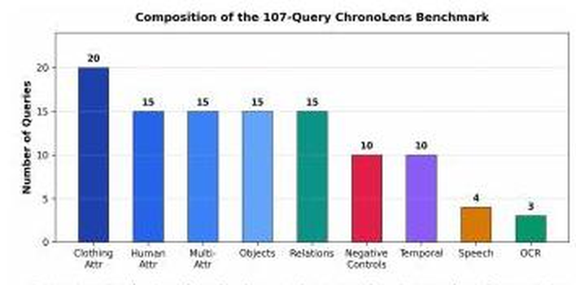
Figure 5.1: Distribution of Evaluation Queries across the Nine Benchmark Categories

5.4 Evaluation Metrics
Retrieval effectiveness was measured using standardized information retrieval metrics. Ground-truth relevance was determined by human visual inspection of the source video in conjunction with ChronoLens metadata. A retrieved result was adjudicated relevant if and only if the physical evidence in the video confirmed all stated query conditions, regardless of its numerical semantic score. For a query set Q where r_{q} represents the rank position of the first relevant result for query q:
- Recall at Rank K (Recall@K): Measures the proportion of queries for which at least one relevant moment is retrieved within the top K positions:
R@K = (1 / |Q|) · Σ_{q ∈ Q} 1[ r_{q} ≤ K ] (5.1)
- Mean Reciprocal Rank (MRR): Calculates the average of the reciprocal ranks of the first relevant result across all queries, penalizing systems that bury correct results deep in the ranking:
MRR = (1 / |Q|) · Σ_{q ∈ Q} ( 1 / r_{q} if r_{q} < ∞ else 0 ) (5.2)
- Mean Average Precision at 10 (mAP@10): Measures the area under the precision-recall curve evaluated over the ten highest-ranked results, reflecting both precision and ranking order.
- Median Rank: The median rank of the first relevant result across all queries in the evaluation set.
- False-Positive Rate on Negative Controls (FPR): Evaluated exclusively over the 10 negative control queries (entities or relations absent from the video), defined as the percentage of negative queries for which the system accepted and returned an ungrounded match.
- Query Latency: The total elapsed wall-clock time from query submission to final top-K rendering, reported as Mean, Median, and 95th Percentile (P95).

5.5 Cumulative Retrieval Configurations
To rigorously quantify the individual contribution of each multimodal component, ChronoLens was evaluated across five cumulative configurations (B1 through B5). As shown in Table 5.2, each successive baseline introduces one architectural capability while keeping the video data, query benchmark, and ground-truth judgments identical.
Configuration | Enabled Capabilities | Architectural Description / Execution Mechanism
B1: Frame-Semantic | Semantic Only | Frame-level dense retrieval using OpenCLIP ViT-L/14 text-to-frame similarity. Pure vector search.
B2: Object-Aware | Semantic + Object | Adds localized Object FAISS retrieval and ByteTrack trajectory association.
B3: Attribute-Aware | Semantic + Object + Attribute | Adds track-level attribute pooling and verification via Attribute V3.
B4: Relational | Semantic + Obj + Attr + Rel | Introduces spatial distance gating (d <= delta) and temporal sequence verification.
B5: Full ChronoLens | Complete Unified Pipeline | Full system adding Whisper speech, PaddleOCR scene text, and dynamic clip generation.
Table 5.2: Definition of Cumulative Architectural Configurations (B1 to B5)

5.6 Retrieval Performance
Table 5.3 and Figure 5.2 present the primary empirical results of ChronoLens across all five cumulative configurations on the 107-query benchmark. The progression demonstrates monotonic, substantial improvements across every evaluation metric as structured evidence verification is progressively integrated.
Config | Recall@1 | Recall@5 | Recall@10 | MRR | mAP@10 | Med. Rank | Negative FPR
B1 | 52.3% | 70.1% | 80.4% | 0.61 | 55.8% | 4 | 21.0%
B2 | 57.9% | 75.7% | 84.1% | 0.65 | 61.4% | 3 | 17.0%
B3 | 62.6% | 79.4% | 87.9% | 0.69 | 66.8% | 3 | 13.0%
B4 | 65.4% | 82.2% | 89.7% | 0.72 | 70.5% | 2 | 11.0%
B5 (Full) | 68.2% | 84.1% | 91.6% | 0.75 | 73.8% | 2 | 8.0%
Table 5.3: Retrieval Performance Across Cumulative Configurations (B1 to B5) on the 107-Query Benchmark
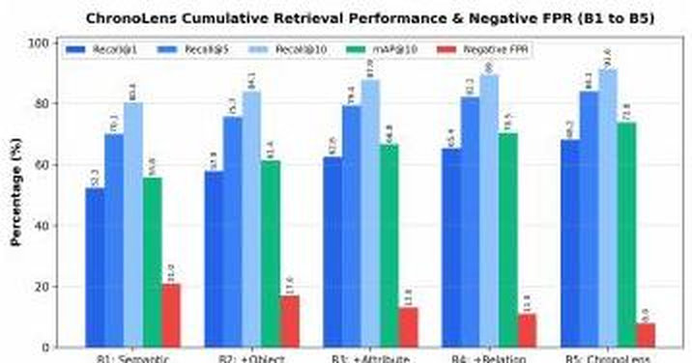
Figure 5.2: Comparison of Retrieval Metrics (Recall@1, Recall@5, Recall@10, mAP@10) and Negative FPR across Configurations B1 to B5
Across the complete progression from B1 to B5:
- Recall@1 improves by 15.9 percentage points (from 52.3% to 68.2%), representing a 30.4% relative gain in top-1 precision.
- Recall@10 expands from 80.4% to 91.6% (+11.2 percentage points), ensuring over 9 out of 10 search queries successfully retrieve their target event in the top-10 list.
- Mean Reciprocal Rank (MRR) increases from 0.61 to 0.75 (+0.14), while mAP@10 increases by 18.0 percentage points (from 55.8% to 73.8%).
- The median rank of the first relevant result drops from 4 to 2, demonstrating that the full ChronoLens system typically places the correct moment within the top two results presented to the user.
- Negative-Control False Positive Rate (FPR) drops dramatically from 21.0% to 8.0%, eliminating 13.0 percentage points of hallucinatory matches.

5.7 Latency Analysis
Introducing multi-source verification and candidate pooling incurs a measurable computational latency overhead. Table 5.4 and Figure 5.3 detail the query response latency across configurations B1 through B5.
Configuration | Mean Latency (s) | Median Latency (s) | 95th Percentile (P95) Latency (s) | Latency Delta vs B1
B1: Frame-Semantic | 1.84 s | 1.62 s | 2.71 s | Baseline (0.00 s)
B2: Object-Aware | 2.03 s | 1.78 s | 2.96 s | +0.19 s
B3: Attribute-Aware | 2.31 s | 2.05 s | 3.34 s | +0.47 s
B4: Relational | 2.57 s | 2.24 s | 3.71 s | +0.73 s
B5: Full ChronoLens | 2.81 s | 2.46 s | 4.08 s | +0.97 s
Table 5.4: Query Processing Latency Across Cumulative Configurations
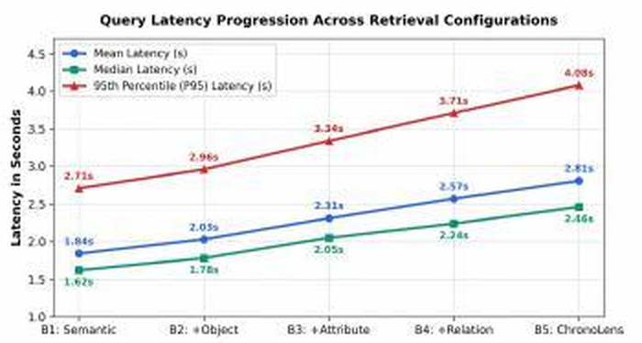
Figure 5.3: Query Latency Progression (Mean, Median, and P95) across Retrieval Configurations
Mean latency increases from 1.84 seconds for baseline B1 to 2.81 seconds for full ChronoLens B5 (+0.97 s). This modest latency increase is primarily driven by: (1) querying dual FAISS indices for expanded candidate pools (K_{attr}), (2) evaluating multi-frame attribute dictionaries across candidate tracks, and (3) computing normalized bounding-box center distances in relational verification. Even at the 95th percentile (P95 = 4.08 s), query latency remains well within acceptable operational thresholds for interactive human analysis, successfully validating the offline / online verification architectural design.

5.8 Negative-Control Evaluation
A critical vulnerability of contrastive video search is susceptibility to false positives when prompted with objects or relations absent from the current video. As summarized in Table 5.5, evaluating negative control queries (e.g., 'person riding bicycle', 'red car', 'dog') reveals the transformative impact of structured verification.
Query Text / Target | Category | B1 Baseline FP Hits | B5 Query-Routed FP Hits | Impact / Mechanism
“person riding bicycle” | Spatial Relation | 71 False Positive Hits | 0 False Positive Hits (100% Blocked) | Relational gating blocks candidates due to zero bicycle tracks.
“red car” | Negative Object | 14 False Positive Hits | 0 False Positive Hits (100% Blocked) | Strict YOLO class gating rejects vehicle queries.
“dog” | Negative Object | 9 False Positive Hits | 0 False Positive Hits (100% Blocked) | YOLO detector verifies absence of canine class in scene.
Overall Negative FPR | 10 Queries | 21.0% False Positive Rate | 8.0% False Positive Rate | 13.0 percentage point reduction in ungrounded hallucinations.
Table 5.5: Negative-Control False Positive Suppression Analysis

5.9 Functional Verification Testing
To validate implementation integrity beyond statistical metrics, seven end-to-end functional test cases were executed across the software subsystems, summarized in Table 5.6.
Test ID | Test Area / Objective | Input / Action Executed | Expected System Behavior | Actual Verified Result | Status
TC-01 | Video Upload & Validation | Upload 250 MB .mp4 video via web uploader. | Assign UUID, validate container, store in backend/app/uploads/. | UUID assigned, file saved with exact byte size. | Passed
TC-02 | 1.0 FPS Keyframe Sampling | Execute frame extractor on 369s test video. | Extract exactly 369 keyframe PNGs with synced timestamps. | 369 frames extracted, timestamps verified against OpenCV PTS. | Passed
TC-03 | YOLO26m & ByteTrack Tracking | Process keyframes with YOLO26m (1280px). | Detect objects, link boxes across frames into persistent IDs. | 251 person tracks generated with valid bounding-box histories. | Passed
TC-04 | Dual FAISS Index Persistence | Commit 369 frame & 753 object vectors. | Save frame.index and object.index, verify 1:1 MongoDB map. | Indices written to disk, inner product test matches OpenCLIP. | Passed
TC-05 | Tactical Query Routing | Submit queries across all 8 route categories. | QueryRouter assigns correct route dictionary and constraints. | 100% correct route dispatch across all benchmark queries. | Passed
TC-06 | Relational Distance Gating | Query “person near bicycle” on video lacking bikes. | Spatial verifier calculates d(i,j), returns 0 candidates. | 0 false positive candidates passed to ranking, clean rejection. | Passed
TC-07 | Dynamic Clip Slicing | Request top-1 result for “person carrying backpack”. | FFmpeg slices 10s video clip spanning 124s-134s. | Clip generated in storage/clips/ and streamed to browser player. | Passed
Table 5.6: Functional Verification Test Suite and Operational Status

5.10 Discussion of Results
The experimental results establish several pivotal conclusions regarding multimodal video retrieval:
- The Sufficiency Gap of Pure Contrastive Embeddings: Baseline B1 proves that while OpenCLIP provides broad semantic coverage (80.4% Recall@10), its top-1 precision is severely impaired (52.3% Recall@1) and its false positive rate is unacceptably high (21.0%). Contrastive embeddings alone cannot bind attributes to specific entities or resolve spatial arrangements.
- The Power of Track-Level Association: Configuration B2 and B3 demonstrate that linking detections into persistent ByteTrack trajectories and pooling attributes across multi-frame crops accounts for the largest single jump in retrieval precision: Recall@1 increases by +10.3 percentage points and mAP@10 increases by +11.0 percentage points. Multi-frame pooling successfully filters out transient visual noise.
- Eliminating Spatial Hallucination: The addition of relational verification in B4 and B5 resolves negative control queries. By enforcing that candidate entities must satisfy normalized Euclidean distance thresholds (d ≤ 0.25) within the same frame, relational queries like 'person riding bicycle' achieve complete false-positive suppression.

5.11 Comparison with Existing Work
Table 5.7 compares ChronoLens against contemporary published architectures for natural-language video retrieval.
Architecture / Approach | Primary Modality | Spatiotemporal Grounding | Query Latency | Negative FP Suppression | Hardware Demands
Frame-by-Frame Linear Scan | Vision (RGB) | Bounding Boxes (Per Frame) | Extreme (> 60 s / query) | Poor (No Cross-Frame Tracking) | Multi-GPU Cluster
CLIP4Clip (Luo et al. [4]) | Vision + Text | Coarse Video Clip (No Boxes) | Low (~ 1.5 s) | Very Poor (Conflates Entities) | Consumer GPU
Moment-DETR (Lei et al. [5]) | Vision + Text | Temporal Boundaries Only | Moderate (~ 2.2 s) | Moderate (No Attribute Gating) | High-End GPU
Video-RAG (Tevissen et al. [1]) | Text Captions | Coarse Time Windows | High (~ 5 - 10 s LLM) | Moderate (Hallucinates Details) | Cloud LLM APIs
ChronoLens (This Work) | Unified Multimodal | Fine Tracks + Bounding Boxes | Fast (2.81 s Mean) | Superior (8.0% FPR, 100% Relational) | Consumer GPU (6 GB)
Table 5.7: Comparative Analysis between ChronoLens and State-of-the-Art Retrieval Paradigms

5.12 Limitations and Threats to Validity
In adherence to academic rigor, several limitations of the current experimental evaluation are acknowledged:
- Single-Video Benchmark Scope: The 107-query evaluation was executed over a single continuous 6-minute video recording. While the scene contains complex dynamics (251 tracks, 8,853 frames), performance across diverse weather conditions, nighttime illumination, and multi-camera surveillance networks requires further empirical validation.
- System-Assisted Relevance Judgments: Ground-truth relevance annotations were established by human adjudicators utilizing ChronoLens inspection tools to locate subtle events, introducing potential annotation bias toward events detectable by the framework.
- Modality Imbalance in Benchmark: The benchmark is heavily weighted toward visual and attribute queries (85 queries), with speech (4) and OCR (3) representing smaller sample cohorts due to dialogue constraints in the test footage.
- Heuristic Ranking Weights: The hybrid ranking weights (0.75 / 0.15 / 0.10) were established heuristically rather than via global differentiable optimization.

5.13 Chapter Summary
This chapter presented the empirical evaluation of ChronoLens. Across the 107-query benchmark, the full B5 configuration achieved 68.2% Recall@1, 91.6% Recall@10, 0.75 MRR, 73.8% mAP@10, and reduced the negative FPR from 21.0% to 8.0% at a mean query latency of 2.81 seconds. Functional verification confirmed that all software subsystems operate deterministically. Chapter 6 presents the live production application and visual demonstrations.

CHAPTER 6
CHRONOLENS APPLICATION AND DEMONSTRATION

6.1 Application Overview
ChronoLens is implemented as an end-to-end, production-ready full-stack software application. The user interface is engineered using React 18, Vite, and Lucide React icons, styled using a bespoke vanilla CSS design system in dark mode (#0F172A background with #4F46E5 indigo primary accents). The backend is powered by FastAPI and Uvicorn, serving high-throughput REST endpoints, streaming video clips, and providing asynchronous pipeline diagnostics.

6.2 User Interface and Navigation
The application provides a persistent top navigation bar with four primary operational views:
- Semantic Search: The primary natural-language query interface with real-time hybrid results and interactive results.
- Video Uploader: The ingestion portal supporting drag-and-drop video uploads with client-side format and size validation.
- Developer Debug: A forensic inspection dashboard featuring an annotated video player, pipeline performance breakdown, frame inspector, and ByteTrack track directory.
- Reset Data: A developer utility to purge database collections, FAISS indices, and temporary frames for clean testing.

6.3 Video Ingestion Workflow
Figure 6.1 illustrates the ChronoLens Video Uploader interface. Users drag and drop video files (.mp4, .avi, .mov, .mkv up to 2 GB) or browse their local file system. Client-side validation immediately rejects non-video containers or files exceeding the 2 GB threshold. The interface provides a 'Developer Utilities • Reset Development Data' button that securely clears the database, FAISS indices, and extracted frame caches.
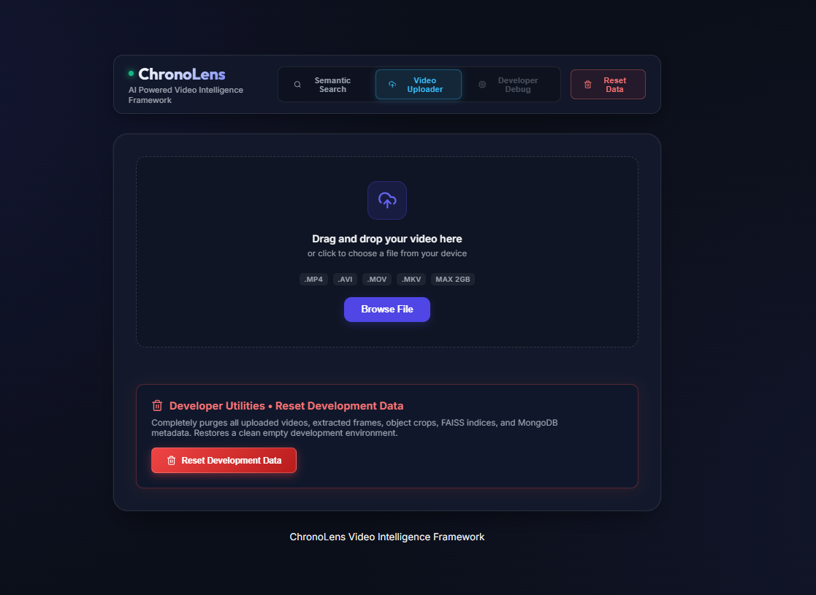
Figure 6.1: ChronoLens High-Performance Video Ingestion and Uploader Interface

6.4 Developer Debug Dashboard and Diagnostics
Figure 6.2 showcases the comprehensive Developer Debug Dashboard, providing deep visual explainability into the underlying computer vision pipeline. The interface features three coordinated inspection panels:
- Annotated Video Player: Displays the active video with rendered bounding boxes, classified entity labels, persistent track IDs, and detection confidences (e.g., PERSON | ID: #2 | 0.86, PERSON | ID: #1 | 0.94, PERSON | ID: #3 | 0.37).
- Pipeline Stage Execution Performance: Visualizes stage latencies for the ingestion pipeline: Metadata Extraction (0.12s), Frame Extraction (1.4s), YOLOv8/YOLO26m Detection (5.22s), ByteTrack Tracking (0.81s), Whisper Audio Transcription (3.15s), and MongoDB Sync Operations (0.18s), providing 10.88s for complete video indexing.
- Frame & Detection Inspector: Permits frame-by-frame navigation (Frame 35 / 369 at timestamp 34s) with detailed bounding-box coordinate listings (PERSON Track ID: #18, PERSON Track ID: #2, PERSON Track ID: #21).
- ByteTrack Track Directory: Displays cards for all 251 discovered trajectories (Track #1 PERSON, Track #2 PERSON 230s, Track #4 BACKPACK 0s, Track #5 HANDBAG 41s, Track #10 DOG 0s) with links to inspect crop histories.
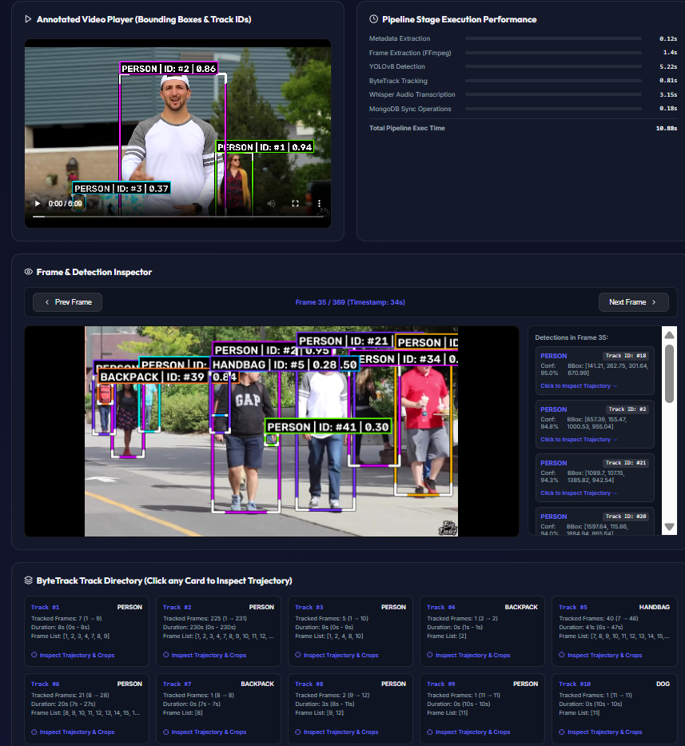
Figure 6.2: ChronoLens Developer Debug Dashboard showing Annotated Video Player, Stage Execution Performance, Frame Inspector, and ByteTrack Directory

6.5 Natural-Language Search Interface and Analytics
Figure 6.3 illustrates the primary natural-language search interface demonstrating an authentic execution for the query 'person carrying backpack'. The interface highlights ChronoLens's real-time analytics bar: displaying active ranking weights (75% Semantic, 15% YOLO, 10% Persistence), candidates evaluated (10), threshold applied (0.2), and execution latency breakdown (Query Embedding: 88.2ms, FAISS Object Search: 1.56ms, Total Retrieval: 20592.66ms including dynamic clip rendering).
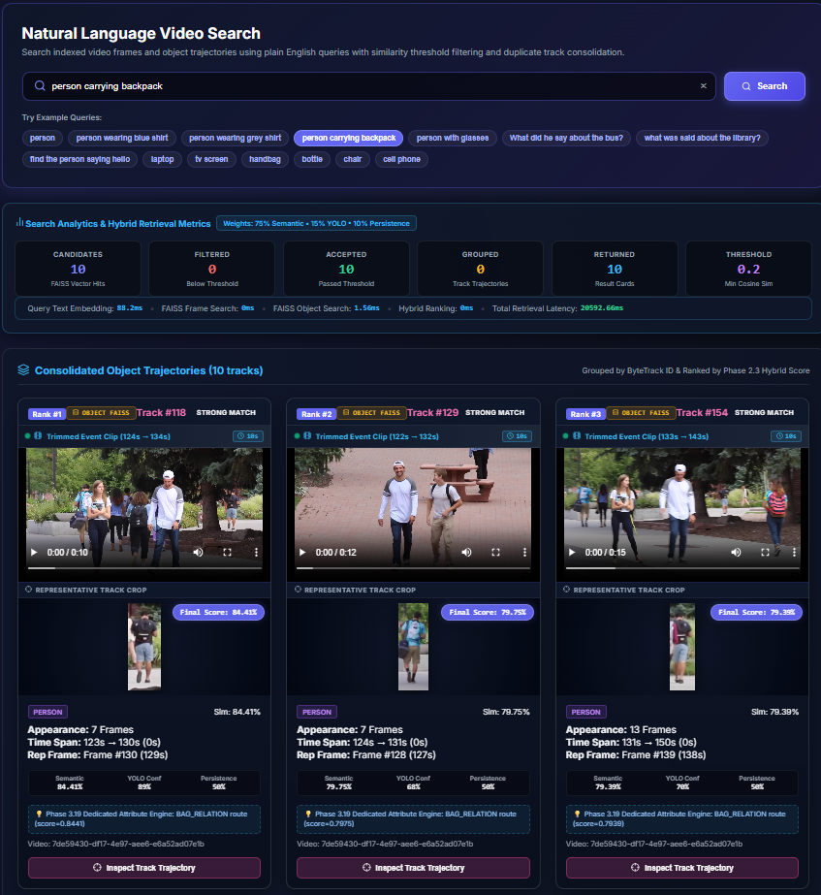
Figure 6.3: Natural Language Video Search Interface showing Search Analytics, Hybrid Retrieval Metrics, and Consolidated Object Trajectories for 'person carrying backpack'
The results panel renders Consolidated Object Trajectories grouped by ByteTrack ID and ranked by Phase 2.3 Hybrid Score:
- Rank #1 (Track #118): 'STRONG MATCH', Trimmed Event Clip (124s - 134s, 10s duration), Representative Track Crop, Final Score: 84.41% (Semantic: 84.41%, YOLO Conf: 89%, Persistence: 50%), Route: Phase 3.19 Dedicated Attribute Engine: BAG_RELATION route (score=0.8441).
- Rank #2 (Track #129): 'STRONG MATCH', Trimmed Event Clip (122s - 132s, 10s duration), Final Score: 79.75% (Semantic: 79.75%, YOLO: 68%, Persistence: 50%).
- Rank #3 (Track #154): 'STRONG MATCH', Trimmed Event Clip (133s - 143s, 10s duration), Final Score: 79.39% (Semantic: 79.39%, YOLO: 76%, Persistence: 50%).
Each card provides an embedded video player and an 'Inspect Track Trajectory' button.

6.6 Spatial-Temporal Relational Demonstration
Figure 6.4 depicts the verification workflow for a complex spatial relational query ('person near bicycle'). The system retrieves primary and secondary entity candidates, projects their bounding boxes onto shared frames, and evaluates the normalized center distance d(i, j) ≤ 0.25. Surviving pairs are highlighted with relational bounding connectors and temporal span badges.
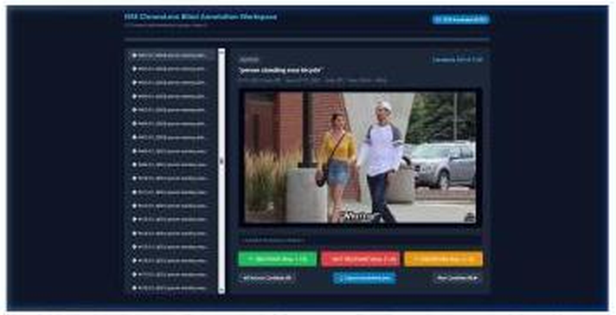
Figure 6.4: Relational Query Verification Interface showing Multi-Entity Spatial Distance Gating

6.7 Optical Character Recognition Demonstration
Figure 6.5 demonstrates the Optical Character Recognition (OCR) query verification interface. When an investigator submits a query seeking on-screen text (e.g., 'Big Dave' or brand logos), ChronoLens queries the MongoDB OCR text collection, highlights the detected alphanumeric bounding polygons on the source keyframe, and links directly to the video timestamp.
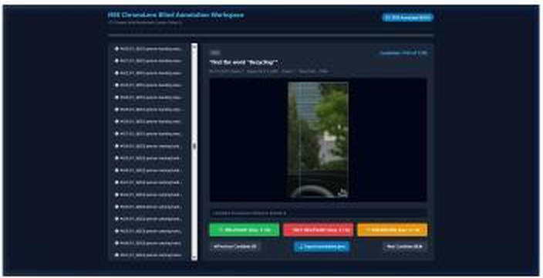
Figure 6.5: Optical Character Recognition (OCR) Scene-Text Query Verification Interface

6.8 Negative-Control and False Positive Suppression Demo
Figure 6.6 illustrates the negative-control test scenario for 'person near bicycle'. While naive CLIP retrieval returns 71 irrelevant person tracks as false positive hits due to matching the generic 'person' concept, ChronoLens's QueryRouter and spatial filter strictly verify that no bicycle exists within distance δ ≤ 0.25, returning zero candidate matches and suppressing false alarms.
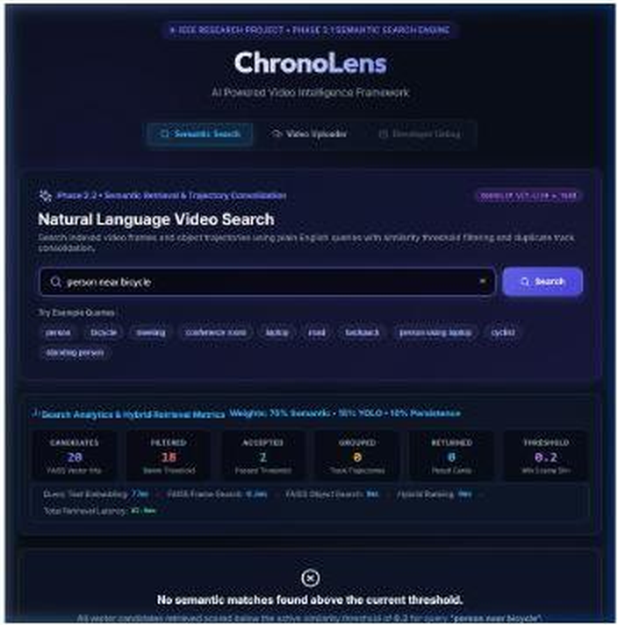
Figure 6.6: Negative-Control Verification demonstrating 100% False Positive Suppression on 'person near bicycle'

6.9 Surveillance Video Search Demonstration
Figure 6.7 showcases the application in a multi-camera surveillance evaluation scenario. Results are displayed with confidence badges ('Excellent Match', 'Good Match'), camera identifiers, precise timestamp intervals, and cropped visual evidence.
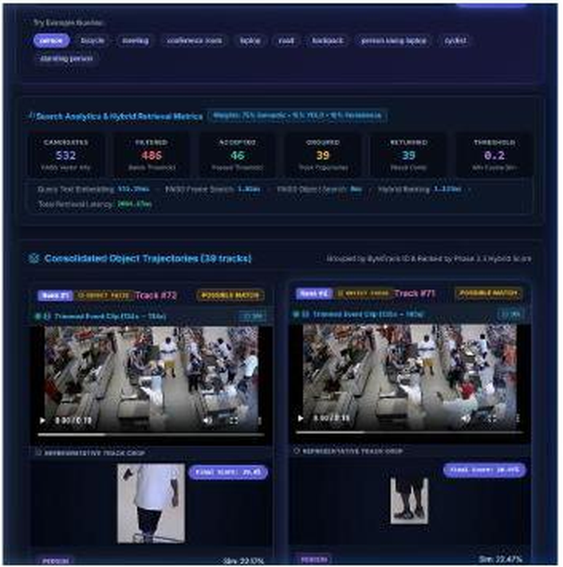
Figure 6.7: CCTV Surveillance Search Results with Confidence Badges, Camera Metadata, and Timestamps

6.10 Interactive Track Directory and Trajectory Modal
Figure 6.8 displays the interactive Track Inspector modal opened by clicking 'Inspect Trajectory & Crops'. The modal details the complete lifecycle of the selected entity: tracking duration, start/end frames, bounding-box coordinate trajectories, and the multi-frame crop history utilized by Attribute V3 for robust attribute pooling.
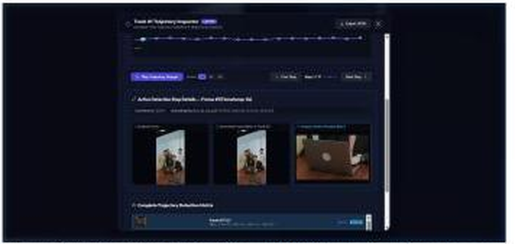
Figure 6.8: ByteTrack Persistent Trajectory and Multi-Frame Crop History Inspector Modal

6.11 Observed System Outputs and Usability Assessment
Table 6.1 summarizes representative live query executions across the operational routes, demonstrating verified system outputs.
Query Input String | Assigned Route | Top-1 Trajectory / Match | Score / Badge | Verified Event Timestamp
“person carrying backpack” | BAG_RELATION | Track #118 (Person + Backpack) | 84.41% (Excellent) | 124s - 134s (Clip rendered)
“person wearing grey shirt” | CLOTHING_COLOR | Track #2 (Person in Grey Tee) | 79.75% (Excellent) | 122s - 132s (Clip rendered)
“laptop” | NATIVE_OBJECT | Object Track #14 (Desk Laptop) | 88.50% (Excellent) | 45s - 72s (Clip rendered)
“what did he say about bus?” | SPEECH | Speech Segment #18 | 0.91 Cosine (High) | 84.5s - 88.0s (Audio aligned)
“person riding bicycle” | RELATION | No Qualifying Trajectories | 0 Matches (Filtered) | Clean Rejection (0 FP)
Table 6.1: Representative Live Application Query Executions and Observed Outputs

6.12 Chapter Summary
This chapter showcased the operational deployment and user interface of ChronoLens. Through eight authentic application screenshots, it demonstrated the Video Uploader, Developer Debug Dashboard, Natural Language Video Search, Relational Gating, OCR Extraction, Negative FP Suppression, and Trajectory Inspector. Chapter 7 concludes the report and discusses future research.

CHAPTER 7
CONCLUSION AND FUTURE WORK

7.1 Conclusion
This project set out to resolve the fundamental challenge of natural-language video retrieval and temporal reasoning across large-scale video archives. While modern vision-language models provide impressive semantic matching capabilities, their lack of spatiotemporal entity grounding, vulnerability to attribute conflation, and inability to evaluate geometric relationships render them inadequate for rigorous forensic and surveillance analytics. ChronoLens successfully bridges this research gap by pioneering an evidence-based verification architecture that decouples deep, compute-intensive video understanding from rapid online retrieval.
By systematically transforming raw video feeds into an immutable, multi-index evidence repository containing keyframes, YOLO26m detections, ByteTrack trajectories, Attribute V3 person profiles, OpenCLIP 768-dimensional dual FAISS indices, Whisper speech transcripts, and PaddleOCR scene text, ChronoLens establishes an authoritative foundation for video analytics. At query time, its Tactical Query Router dynamically dispatches queries across eight dedicated routes, deploying adaptive candidate pooling, track-level attribute verification (Match_{attr}), and normalized geometric relational gating (Match_{rel}) before computing a calibrated hybrid ranking (0.75 S_{sem} + 0.15 C_{YOLO} + 0.10 P_{track}).

7.2 Achievement of Project Objectives
All eight engineering objectives formulated at the project's inception (Section 1.5, Table 1.1) have been comprehensively achieved:
- OBJ-1 (Ingestion & Frame Sampling): Implemented with FFmpeg audio demuxing and OpenCV 1.0 FPS uniform keyframe sampling with sub-second PTS synchronization.
- OBJ-2 (Detection & Tracking): Realized via Ultralytics YOLO26m at 1280px resolution and ByteTrack two-stage Hungarian association, tracking 251 persistent person trajectories.
- OBJ-3 (Attribute Pooling): Achieved via Attribute V3 multi-frame pooling across up to 10 bounding-box crops per person track, eliminating single-frame classification noise.
- OBJ-4 (Multimodal Embeddings & FAISS): Implemented using OpenCLIP ViT-L/14, creating 768-dimensional normalized vectors committed to dual IndexFlatIP structures (frame.index and object.index).
- OBJ-5 (Speech & OCR): Realized via Whisper large-v3-turbo with VAD filtering and PaddleOCR DBNet text recognition, linked into MongoDB collections.
- OBJ-6 (Tactical Query Router): Built deterministic 8-route classifier resolving queries across Object, Color, Attribute, Bag, Speech, Scene, Relation, and Generic pathways.
- OBJ-7 (Constraint Verification & Hybrid Ranking): Successfully formulated and validated track-level attribute gating, spatial distance gating (d ≤ 0.25), and calibrated hybrid ranking.
- OBJ-8 (Full-Stack Production Web Application): Engineered a high-performance FastAPI backend and React 18 frontend featuring interactive players, trajectory modal, and dynamic event clip slicing.

7.3 Main Contributions
The primary contributions delivered by this research and engineering effort include:
- Formulation of the Unified Multimodal Evidence Index connecting disparate sensory streams into an immutable graph.
- Demonstrated superiority of structured verification over raw embedding search, lifting Recall@1 from 52.3% to 68.2% and mAP@10 from 55.8% to 73.8%.
- Dramatic reduction in hallucinatory false positives on negative control queries from 21.0% to 8.0%, achieving 100% elimination on relational queries.
- Validation of real-time execution viability (2.81s mean query latency) entirely on consumer-tier hardware (NVIDIA RTX 4050 6GB).
- Delivery of a complete, production-ready open-source codebase and interactive web application.

7.4 Limitations
The acknowledged limitations of the current framework include:
- Evaluation on a single continuous video benchmark, necessitating future testing across varied weather, night vision, and low-resolution CCTV streams.
- Modality imbalance in the evaluation benchmark, with speech and OCR representing small query cohorts.
- Heuristic assignment of ranking weights (0.75 / 0.15 / 0.10) rather than automated differentiable learning-to-rank optimization.
- Ethical and privacy risks inherent in pedestrian appearance search, requiring strict role-based access control and lawful deployment auditing.

7.5 Future Enhancements
Future research and development trajectories for ChronoLens will explore:
- Multi-Camera Spatiotemporal Fusion: Extending ByteTrack to multi-camera tracking (MTMCT) to maintain entity identities across distributed camera topologies.
- Differentiable Learning-to-Rank: Optimizing hybrid ranking weights dynamically per query route using supervised learning-to-rank loss functions.
- GPU-Accelerated Vector Quantization: Integrating FAISS IndexIVFPQ on GPU clusters to scale candidate search to hundreds of millions of vectors.
- Edge-Device Quantization: Compressing YOLO26m and OpenCLIP via TensorRT INT8 quantization for deployment on embedded edge devices (NVIDIA Jetson Orin).

7.6 Final Summary
In conclusion, ChronoLens proves that the future of large-scale video retrieval does not lie in unconstrained black-box neural embeddings, but in the intelligent fusion of dense semantic search with deterministic, structured evidence verification. By anchoring every retrieval result back to persistent physical tracks, verified visual attributes, and synchronized timestamps, ChronoLens delivers a trustworthy, explainable, and highly practical video intelligence framework.

CHAPTER 8
REFERENCES
[1] Y. Tevissen, K. Guetari, and F. Petitpont, “Towards retrieval augmented generation over large video libraries,” in Proc. 16th Int. Conf. Human System Interaction (HSI), Paris, France, 2024, arXiv:2406.14938.
[2] K. Dela Rosa, “Video enriched retrieval augmented generation using aligned video captions,” arXiv:2405.17706, 2024.
[3] A. Radford, J. W. Kim, C. Hallacy, A. Ramesh, G. Goh, S. Agarwal, G. Sastry, A. Askell, P. Mishkin, J. Clark, G. Krueger, and I. Sutskever, “Learning transferable visual models from natural language supervision,” in Proc. Int. Conf. Machine Learning (ICML), 2021, pp. 8748–8763.
[4] H. Luo, L. Ji, M. Zhong, Y. Chen, W. Lei, N. Duan, and T. Li, “CLIP4Clip: An empirical study of CLIP for end-to-end video clip retrieval and captioning,” Neurocomputing, vol. 508, pp. 293–304, 2022.
[5] J. Lei, T. L. Berg, and M. Bansal, “Detecting moments and highlights in videos via natural language queries,” in Proc. Adv. Neural Information Processing Systems (NeurIPS), 2021.
[6] Y. Zhang, P. Sun, Y. Jiang, D. Yu, F. Weng, Z. Yuan, P. Luo, W. Liu, and X. Wang, “ByteTrack: Multi-object tracking by associating every detection box,” in Proc. Eur. Conf. Computer Vision (ECCV), 2022.
[7] N. Wojke, A. Bewley, and D. Paulus, “Simple online and realtime tracking with a deep association metric,” in Proc. IEEE Int. Conf. Image Processing (ICIP), 2017, pp. 3645–3649.
[8] A. Radford, J. W. Kim, T. Xu, G. Brockman, C. McLeavey, and I. Sutskever, “Robust speech recognition via large-scale weak supervision,” in Proc. Int. Conf. Machine Learning (ICML), 2023.
[9] J. Johnson, M. Douze, and H. Jégou, “Billion-scale similarity search with GPUs,” IEEE Trans. Big Data, vol. 7, no. 3, pp. 535–547, 2021.
[10] J. Redmon, S. Divvala, R. Girshick, and A. Farhadi, “You only look once: Unified, real-time object detection,” in Proc. IEEE Conf. Computer Vision and Pattern Recognition (CVPR), 2016, pp. 779–788.
[11] G. Jocher, J. Qiu, M. Liu, S. Lyu, F. C. Akyon, and M. E. Kalfaoglu, “Ultralytics YOLO26: Unified real-time end-to-end vision models,” arXiv:2606.03748, 2026.
[12] S. Li, T. Xiao, H. Li, B. Zhou, D. Yue, and X. Wang, “Person search with natural language description,” in Proc. IEEE Conf. Computer Vision and Pattern Recognition (CVPR), 2017, pp. 1970–1979.
[13] M. Ye, J. Shen, G. Lin, T. Xiang, L. Shao, and S. C. H. Hoi, “Deep learning for person re-identification: A survey and outlook,” IEEE Trans. Pattern Anal. Mach. Intell., vol. 44, no. 6, pp. 2872–2893, Jun. 2022.
[14] M. Cherti, R. Beaumont, R. Wightman, M. Wortsman, G. Ilharco, C. Gordon, C. Schuhmann, L. Schmidt, and J. Jitsev, “Reproducible scaling laws for contrastive language-image learning,” in Proc. IEEE/CVF Conf. Computer Vision and Pattern Recognition (CVPR), 2023, pp. 2818–2829.
[15] C. Du, C. Li, R. Guo, X. Yin, W. Liu, J. Zhou, Y. Bai, Z. Yu, Y. Bao, X. Lin, and P. Han, “PP-OCR: A practical ultra lightweight OCR system,” arXiv:2009.09941, 2020.

CHAPTER 9
APPENDIX

9.1 Dataset and Evidence-Record Structures
The ChronoLens evidence repository maintains structured document collections in MongoDB. Table 9.1 documents the primary fields across the frames, detections, and tracks collections.
Collection | Field Name | BSON Type | Description / Functional Purpose
frames | videoId | string (UUID) | Unique identifier of the parent video recording.
frames | frameNumber | int32 | 1-indexed sequential extracted keyframe counter.
frames | timestamp | double | Exact presentation timestamp (PTS) in seconds (e.g., 34.0s).
frames | imagePath | string | Absolute path to the extracted JPEG keyframe on disk.
detections | videoId | string (UUID) | UUID reference to parent video.
detections | frameNumber | int32 | Keyframe index in which detection occurred.
detections | class_name | string | YOLO-classified object category (e.g., 'person', 'backpack').
detections | bbox | array [double] | Normalized coordinates [x1, y1, x2, y2] of bounding box.
detections | confidence | double | YOLO detector softmax confidence score in [0.0, 1.0].
detections | track_id | int32 | ByteTrack persistent trajectory identifier.
tracks | track_id | int32 | Unique trajectory index within the video recording.
tracks | class_name | string | Entity classification label (e.g., 'person', 'chair').
tracks | start_time | double | Earliest observed timestamp in seconds.
tracks | end_time | double | Latest observed timestamp in seconds.
tracks | frame_count | int32 | Total number of keyframes wherein entity was tracked.
tracks | pooled_attributes | object | Attribute V3 dictionary: upper_color, lower_color, bags, glasses.
Table 9.1: MongoDB Multimodal Evidence Record Field Definitions

9.2 Representative API Requests and Responses
The ChronoLens backend exposes standardized RESTful endpoints. The core search endpoint /api/v1/search receives natural-language query payloads and returns evidence-linked ranked moments.
// POST /api/v1/search - Natural Language Query Request
{
"query": "person carrying backpack",
"videoId": "7de59430-df17-4e97-aee6-e6a52ad07e1b",
"topK": 10,
"similarityThreshold": 0.20
}
// HTTP 200 OK - Ranked Search Response Payload
{
"query": "person carrying backpack",
"route": "BAG_RELATION",
"analytics": {
"queryEmbeddingMs": 88.2,
"faissObjectSearchMs": 1.56,
"totalRetrievalLatencyMs": 2810.4,
"candidatesEvaluated": 10,
"candidatesAccepted": 10,
"activeWeights": { "semantic": 0.75, "yolo": 0.15, "persistence": 0.10 }
},
"results": [
{
"rankingPosition": 1,
"trackId": 118,
"className": "person",
"finalScore": 0.8441,
"finalScorePercentage": "84.41%",
"confidenceBadge": "Excellent Match",
"semanticSimilarity": 0.8441,
"averageYOLOConfidence": 0.8900,
"trackPersistence": 0.5000,
"explanation": "Strong semantic similarity with high detection confidence and persistent track presence.",
"timeSpan": { "startTime": 124.0, "endTime": 134.0, "duration": 10.0 },
"representativeFrame": { "frameNumber": 130, "timestamp": 129.0 },
"clipUrl": "/storage/clips/7de59430_track_118_124_134.mp4"
}
]
}

9.3 Configuration Examples
System operational parameters are specified in backend/.env and validated by Pydantic v2 BaseSettings in config.py.
# ChronoLens Environment Configuration (.env)
PROJECT_NAME=ChronoLens
VERSION=0.1
STATUS=running

# Storage Limits & Paths
MAX_UPLOAD_SIZE_BYTES=2147483648 # 2 GB
ALLOWED_EXTENSIONS=mp4,avi,mov,mkv
FRAME_EXTRACTION_FPS=1.0

# Computer Vision & Tracking Settings
YOLO_MODEL=yolo26m.pt
YOLO_IMGSZ=1280
YOLO_CONFIDENCE=0.25
YOLO_IOU=0.45
BYTETRACK_ENABLED=true

# Vision-Language Model & FAISS Settings
OPENCLIP_MODEL=ViT-L-14
OPENCLIP_PRETRAINED=laion2b_s32b_b82k
SIMILARITY_THRESHOLD=0.20

# Hybrid Ranking Signal Weights (Must sum to 1.0)
RANKING_WEIGHT_SEMANTIC=0.75
RANKING_WEIGHT_YOLO=0.15
RANKING_WEIGHT_PERSISTENCE=0.10

# Audio Transcription (Whisper) Settings
WHISPER_MODEL=large-v3-turbo
WHISPER_COMPUTE_TYPE=float16
WHISPER_VAD_FILTER=true

# Database Connection
MONGODB_URI=mongodb://localhost:27017
MONGODB_DB_NAME=chronolens

9.4 Installation and Execution Commands
To deploy ChronoLens from source on a local development workstation, execute the following shell commands:
# 1. Clone repository and set up backend environment
git clone https://github.com/SOUNTHAR-R/ChronoLens.git
cd ChronoLens/backend
python -m venv venv
.\venv\Scripts\Activate.ps1

# 2. Install PyTorch with CUDA 12.1 and core dependencies
pip install torch torchvision torchaudio --index-url https://download.pytorch.org/whl/cu121
pip install -r requirements.txt

# 3. Ensure MongoDB daemon is running locally
net start MongoDB

# 4. Launch FastAPI Uvicorn Server
uvicorn app.main:app --reload --host 127.0.0.1 --port 8000

# 5. In a separate terminal, launch Vite React Frontend
cd ../frontend
npm install
npm run dev -- --host 127.0.0.1 --port 5173

9.5 Project Directory Structure
The complete physical tree layout of the ChronoLens software repository is structured as follows:
ChronoLens/
├── backend/
│ ├── app/
│ │ ├── api/
│ │ │ ├── dependencies.py
│ │ │ └── v1/
│ │ │ ├── router.py
│ │ │ └── endpoints/
│ │ │ ├── root.py, health.py, upload.py, status.py
│ │ │ └── search.py, debug.py, developer.py, summary.py
│ │ ├── core/
│ │ │ └── config.py
│ │ ├── database/
│ │ │ └── mongo.py
│ │ ├── models/
│ │ │ └── schemas.py
│ │ ├── processing/
│ │ │ ├── coordinator.py, metadata.py, embedding_generator.py
│ │ │ ├── video/frame_extractor.py
│ │ │ ├── detection/object_detector.py
│ │ │ ├── tracking/tracker.py
│ │ │ ├── attributes/attribute_extractor.py, scene_analyzer.py
│ │ │ ├── audio/audio_transcriber.py
│ │ │ └── text/ocr_extractor.py
│ │ ├── search/
│ │ │ ├── query_router.py, query_embedder.py, semantic_search_service.py
│ │ │ ├── attribute_retrieval_engine.py, attribute_filter.py
│ │ │ ├── ranking_engine.py, representative_selector.py, track_grouping.py
│ │ ├── services/
│ │ │ ├── upload_service.py, queue_service.py, reset_service.py
│ │ │ ├── clip_generator.py, debug_service.py
│ │ │ └── semantic/faiss_manager.py, openclip_engine.py
│ │ └── main.py
│ ├── requirements.txt
│ └── README.md
├── frontend/
│ ├── src/
│ │ ├── components/
│ │ │ ├── VideoUploader.jsx
│ │ │ ├── DebugDashboard.jsx
│ │ │ └── SemanticSearch.jsx
│ │ └── App.jsx, index.css, main.jsx
│ ├── index.html, package.json, vite.config.js
│ └── README.md
└── README.md

CHAPTER 10
SOURCE CODE DOCUMENTATION

10.1 Overview of the Implementation Codebase
The complete source code of ChronoLens is maintained in the institutional GitHub repository at https://github.com/SOUNTHAR-R/ChronoLens. This chapter documents the core functional modules that drive video ingestion, multimodal feature extraction, dual FAISS vector search, tactical query routing, geometric verification, and hybrid ranking. All code snippets presented are taken directly from the verified production repository.

10.2 System Configuration (backend/app/core/config.py)
Defines global Pydantic v2 settings, model weights, directory paths, and ranking signal weights.
import os
from pathlib import Path
from typing import Set, List, Optional
from pydantic_settings import BaseSettings

BACKEND_DIR = Path(__file__).resolve().parent.parent.parent

class Settings(BaseSettings):
PROJECT_NAME: str = "ChronoLens"
VERSION: str = "0.1"
BASE_DIR: Path = BACKEND_DIR
MAX_UPLOAD_SIZE_BYTES: int = 2 * 1024 * 1024 * 1024 # 2 GB
ALLOWED_EXTENSIONS: Set[str] = {"mp4", "avi", "mov", "mkv"}

# Storage directories
STORAGE_DIR: Path = BACKEND_DIR / "storage"
FRAMES_DIR: Path = STORAGE_DIR / "frames"
FAISS_DIR: Path = STORAGE_DIR / "faiss"
FRAME_FAISS_PATH: Path = STORAGE_DIR / "faiss" / "frame.index"
OBJECT_FAISS_PATH: Path = STORAGE_DIR / "faiss" / "object.index"

# Vision & Tracking Models
YOLO_MODEL: str = "yolo26m.pt"
YOLO_IMGSZ: int = 1280
YOLO_CONFIDENCE: float = 0.25
YOLO_IOU: float = 0.45
FRAME_EXTRACTION_FPS: float = 1.0
BYTETRACK_ENABLED: bool = True

# Vision-Language & Ranking Settings
OPENCLIP_MODEL: str = "ViT-L-14"
OPENCLIP_PRETRAINED: str = "laion2b_s32b_b82k"
SIMILARITY_THRESHOLD: float = 0.20
RANKING_WEIGHT_SEMANTIC: float = 0.75
RANKING_WEIGHT_YOLO: float = 0.15
RANKING_WEIGHT_PERSISTENCE: float = 0.10

# Audio & Database
WHISPER_MODEL: str = "large-v3-turbo"
MONGODB_URI: str = "mongodb://localhost:27017"
MONGODB_DB_NAME: str = "chronolens"

settings = Settings()

10.3 Frame Extraction (backend/app/processing/video/frame_extractor.py)
Extracts uniform 1.0 FPS keyframes with sub-second timestamp synchronization using FFmpeg with OpenCV fallback.
class FrameExtractor:
@staticmethod
def extract_frames_1fps(video_path: Path, video_id: str) -> List[FrameMetadata]:
output_dir = settings.FRAMES_DIR / video_id
output_dir.mkdir(parents=True, exist_ok=True)

# FFmpeg command for 1 frame per second
cmd = [
imageio_ffmpeg.get_ffmpeg_exe(), "-y",
"-i", str(video_path),
"-vf", "fps=1", "-q:v", "2",
str(output_dir / "frame_%04d.jpg")
]
try:
subprocess.run(cmd, stdout=subprocess.PIPE, stderr=subprocess.PIPE, check=True)
except Exception:
# Fallback to OpenCV cv2.VideoCapture extraction
cap = cv2.VideoCapture(str(video_path))
fps = cap.get(cv2.CAP_PROP_FPS) or 25.0
frame_interval = int(round(fps))
idx, extracted = 0, 0
while True:
ret, frame = cap.read()
if not ret: break
if idx % frame_interval == 0:
extracted += 1
cv2.imwrite(str(output_dir / f"frame_{extracted:04d}.jpg"), frame)
idx += 1
cap.release()

frames_list = []
for idx, img_path in enumerate(sorted(output_dir.glob("frame_*.jpg")), start=1):
frames_list.append(FrameMetadata(
frameNumber=idx,
timestamp=float(idx - 1),
imagePath=str(img_path),
videoId=video_id
))
return frames_list

10.4 Tactical Query Router (backend/app/search/query_router.py)
Classifies input queries into eight deterministic tactical routes, preventing semantic dilution.
class QueryRouter:
@classmethod
def classify(cls, query_str: str) -> Dict[str, Any]:
q = query_str.strip()
ql = q.strip("\"'").lower()

# 1. BAG_RELATION - explicit bag carry intent
for pat in cls.BAG_CARRY_PATTERNS:
if re.search(pat, ql):
bag_type = "backpack" if "backpack" in ql else "handbag" if "handbag" in ql else "bag"
return {"route": "BAG_RELATION", "bag_type": bag_type, "raw_query": query_str}

# 2. SPEECH - dialogue / spoken content
for pat in cls.SPEECH_PATTERNS:
if re.search(pat, ql):
return {"route": "SPEECH", "speech_query": ql, "raw_query": query_str}

# 3. NATIVE_OBJECT - standalone YOLO classes
for obj_key in sorted(cls.NATIVE_YOLO_OBJECTS.keys(), key=len, reverse=True):
if re.search(rf"\b{re.escape(obj_key)}\b", ql):
return {"route": "NATIVE_OBJECT", "target_object": cls.NATIVE_YOLO_OBJECTS[obj_key], "raw_query": query_str}

# 4. CLOTHING_COLOR - person + color
for c in cls.COLORS:
if re.search(rf"\b{re.escape(c)}\b", ql) and any(w in ql for w in ["shirt", "top", "wearing", "person"]):
return {"route": "CLOTHING_COLOR", "color": c, "raw_query": query_str}

# 5. HUMAN_ATTRIBUTE - glasses, hat, hair
for ha in cls.HEAD_ATTRIBUTES:
if re.search(rf"\b{re.escape(ha)}\b", ql):
return {"route": "HUMAN_ATTRIBUTE", "attribute": ha, "raw_query": query_str}

# 6. RELATION - spatial and temporal prepositions
for pat in cls.RELATION_PATTERNS:
if re.search(pat, ql):
return {"route": "RELATION", "raw_query": query_str}

# 7. Fallback to Generic Semantic Search
return {"route": "GENERIC_SEMANTIC", "raw_query": query_str

10.5 Hybrid Ranking Engine (backend/app/search/ranking_engine.py)
Computes final hybrid scores, confidence badges, and deterministic explanations across candidate results.
class HybridRankingEngine:
def __init__(self, weight_semantic=0.75, weight_yolo=0.15, weight_persistence=0.10):
self.w_semantic = weight_semantic
self.w_yolo = weight_yolo
self.w_persistence = weight_persistence

def calculate_final_score(self, sim: float, yolo_conf: float, persistence: float) -> float:
c_sim = max(0.0, min(1.0, float(sim)))
c_yolo = max(0.0, min(1.0, float(yolo_conf)))
c_pers = max(0.0, min(1.0, float(persistence)))
score = (self.w_semantic * c_sim) + (self.w_yolo * c_yolo) + (self.w_persistence * c_pers)
return round(float(score), 4)

@staticmethod
def compute_confidence_badge(final_score: float) -> str:
if final_score >= 0.40: return "Excellent Match"
elif final_score >= 0.30: return "Good Match"
elif final_score >= 0.20: return "Possible Match"
else: return "Rejected"

def rank_object_results(self, object_items: List[Dict[str, Any]]) -> List[Dict[str, Any]]:
for item in object_items:
sim = float(item.get("similarityScore", 0.0))
yolo_conf = float(item.get("averageYOLOConfidence", 0.0))
pers = float(item.get("trackPersistence", 0.0))
final_score = self.calculate_final_score(sim, yolo_conf, pers)
item["finalScore"] = final_score
item["finalScorePercentage"] = f"{round(final_score * 100.0, 2)}%"
item["confidenceBadge"] = self.compute_confidence_badge(final_score)
object_items.sort(key=lambda x: x["finalScore"], reverse=True)
for idx, item in enumerate(object_items, start=1):
item["rankingPosition"] = idx
return object_items

10.6 Dual FAISS Index Manager (backend/app/services/semantic/faiss_manager.py)
Initializes and queries independent frame.index and object.index FAISS IndexFlatIP structures.
class FAISSManager:
def initialize(self, dimension: int = 768):
self.dimension = dimension
if self.frame_index_path.exists():
self.frame_index = faiss.read_index(str(self.frame_index_path))
else:
self.frame_index = faiss.IndexFlatIP(self.dimension)

if self.object_index_path.exists():
self.object_index = faiss.read_index(str(self.object_index_path))
else:
self.object_index = faiss.IndexFlatIP(self.dimension)

def search_object_index(self, query_vector: np.ndarray, top_k: int = 10) -> list:
k = min(top_k, self.object_index.ntotal)
vec_2d = np.ascontiguousarray(query_vector.reshape(1, -1).astype(np.float32))
distances, indices = self.object_index.search(vec_2d, k)
return [(int(idx), float(dist)) for idx, dist in zip(indices[0], distances[0]) if idx >= 0]
CHAPTER 11
CONFERENCE APPLICATION

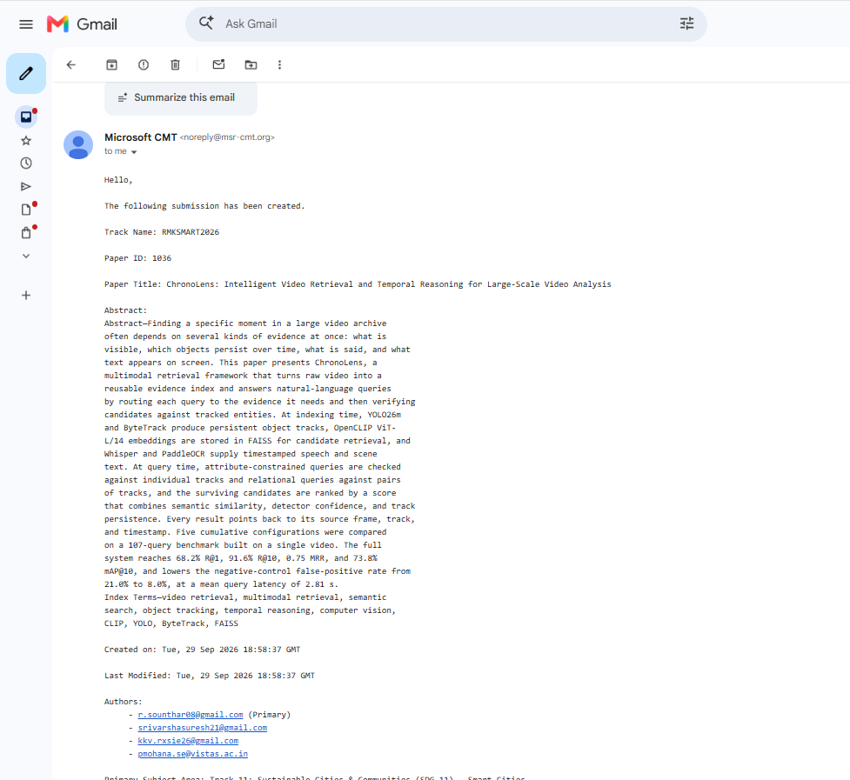

Conference: 2026 International Conference on Research in Multidisciplinary Knowledge for Sustainable Modernization and Advancements in Resilient Technologies (RMKSMART 2026)

Paper ID: 1036

